**Course Description**

Scientists seek to answer questions using rigorous methods and careful observations. These observations—collected from the likes of field notes, surveys, and experiments—form the backbone of a statistical investigation and are called data.

Statistics is the study of how best to collect, analyze, and draw conclusions from data. It is helpful to put statistics in the context of a general process of investigation:

1) identify a question or problem;   
2) collect relevant data on the topic;   
3) analyze the data; and   
4) form a conclusion.

In this course, we'll focus on the first two steps of the process.

**Language of data**This chapter introduces terminology of datasets and data frames in R.



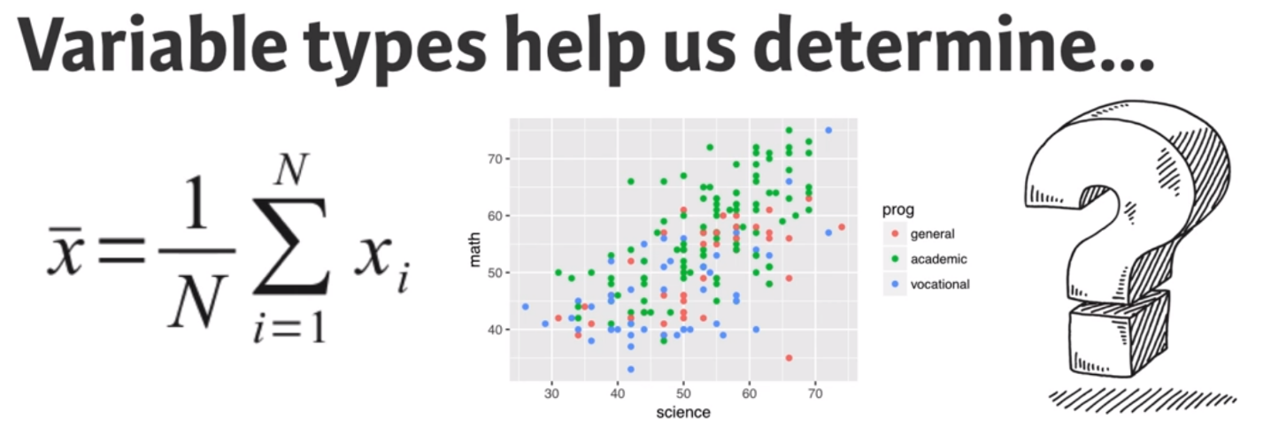

Variable types help us to determine what summary statistics to calculate, what type of visualizations to make, and what statistical method will be appropriate to answer the research questions we are exploring.

# Loading data into R

In the previous video, we saw how to load the hsb2 dataset into R using the data() function and how to preview its contents with str().

In this exercise, we'll practice on another dataset, email50, which contains a subset of incoming emails for the first three months of 2012 for a single email account. We'll examine the structure of this dataset and determine the number of rows (observations) and columns (variables).

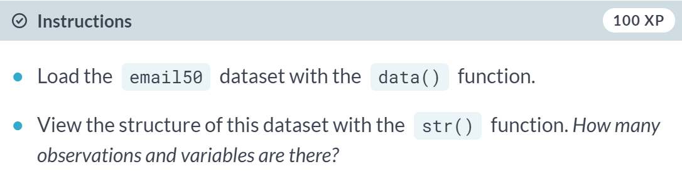

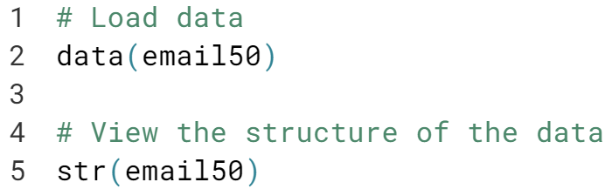

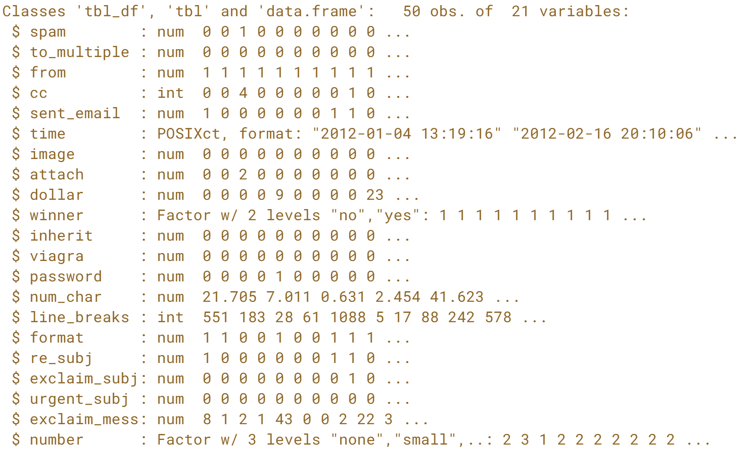

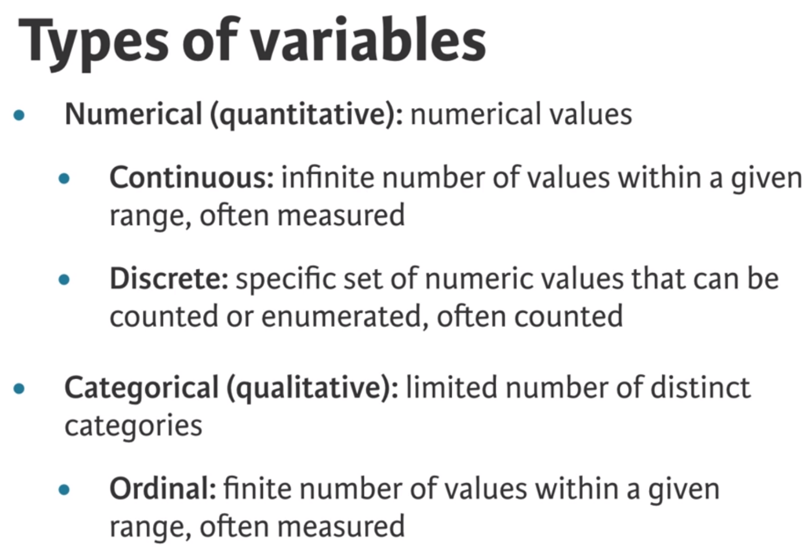

# Identify variable types

Recall from the video that the glimpse() function from dplyr provides a handy alternative to str() for previewing a dataset. In addition to the number of observations and variables, it shows the name and type of each column, along with a neatly printed preview of its values.

Let's have another look at the email50 data, so we can practice identifying variable types.

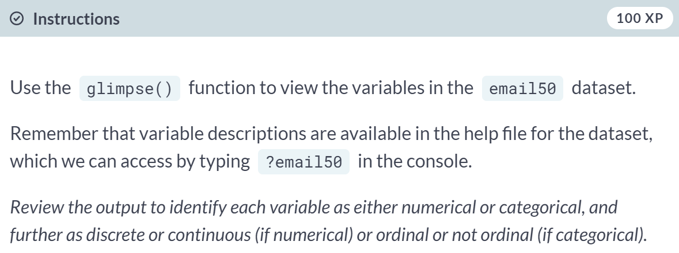

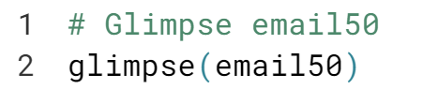  
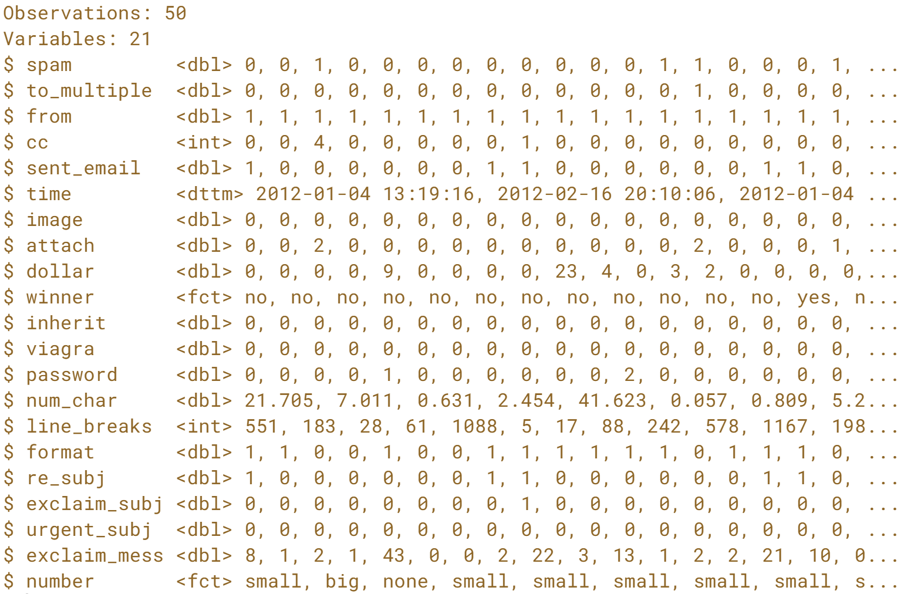

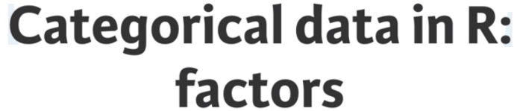

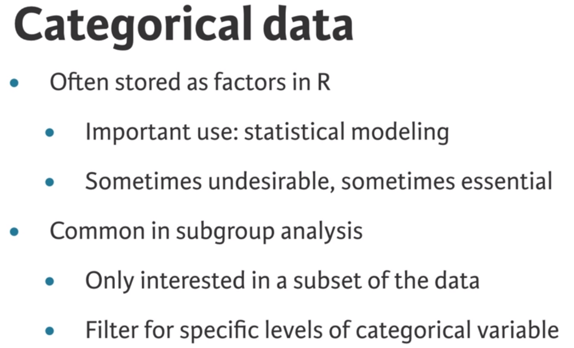

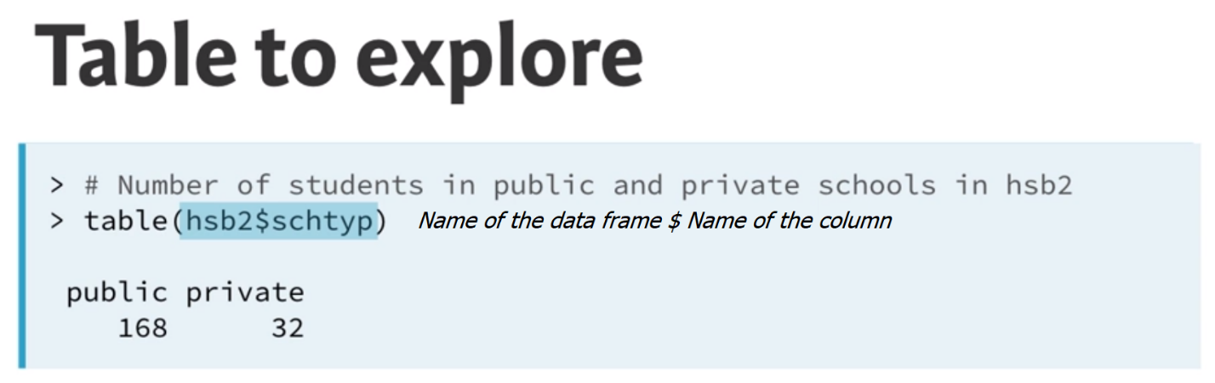  
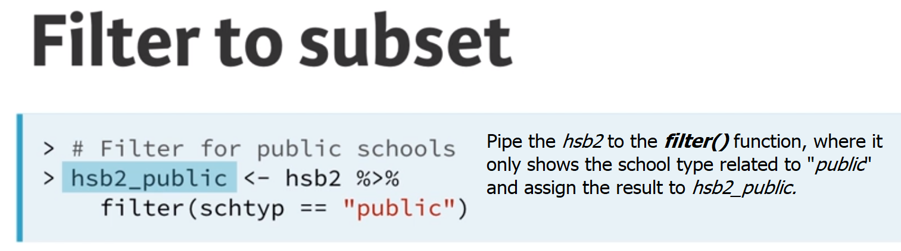

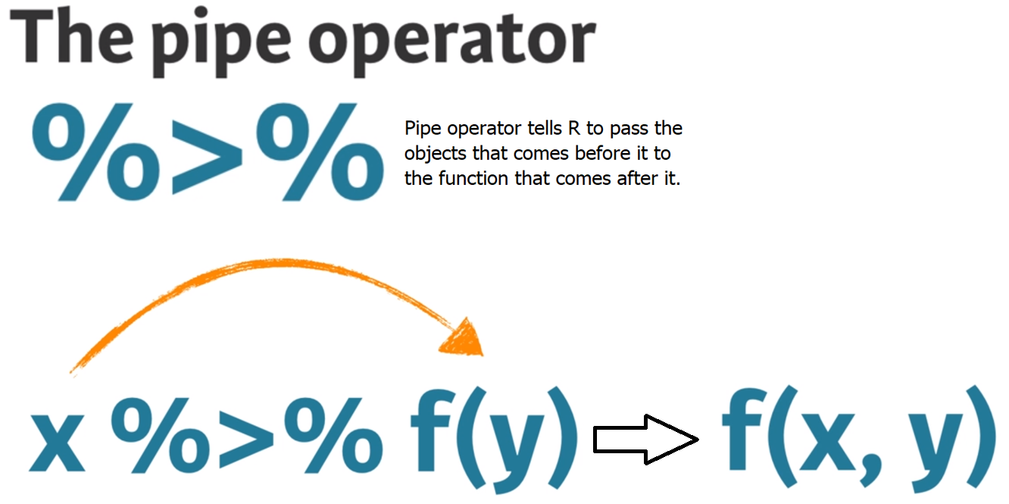  
  
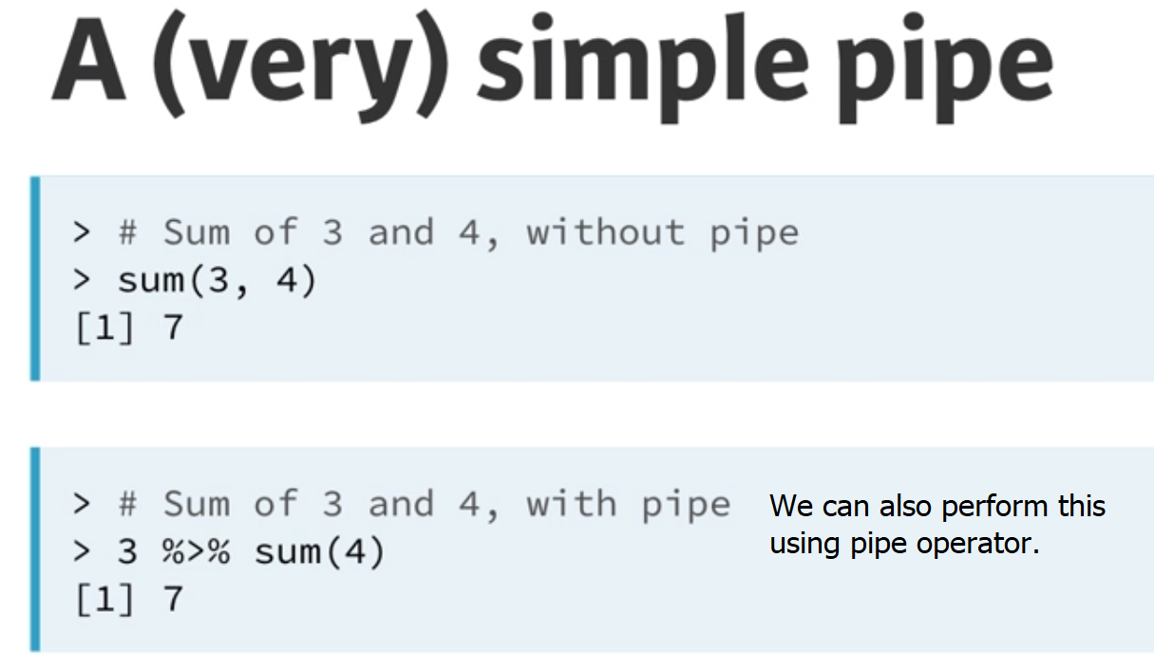  
Pipe operator is commonly used in functions in dplyr package, and it allows us to sequentially build data wrangling operations

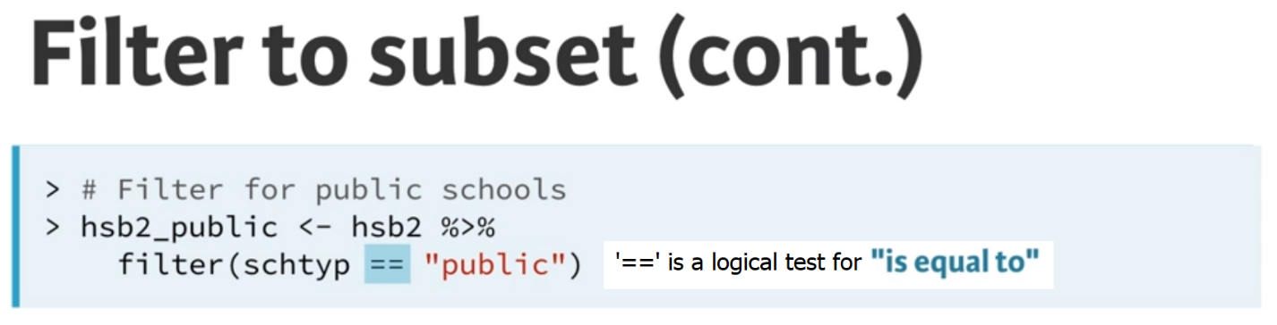

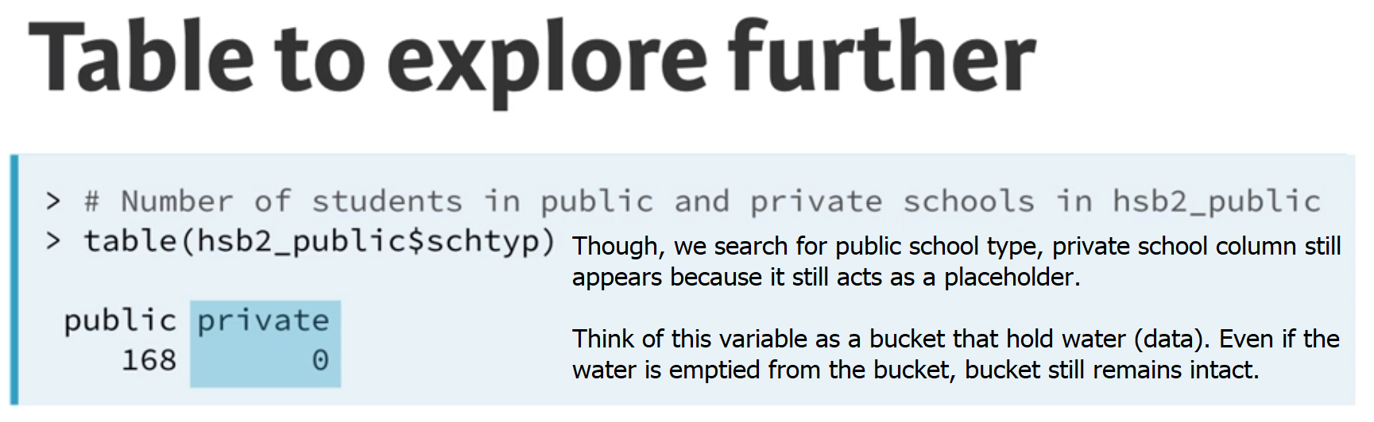

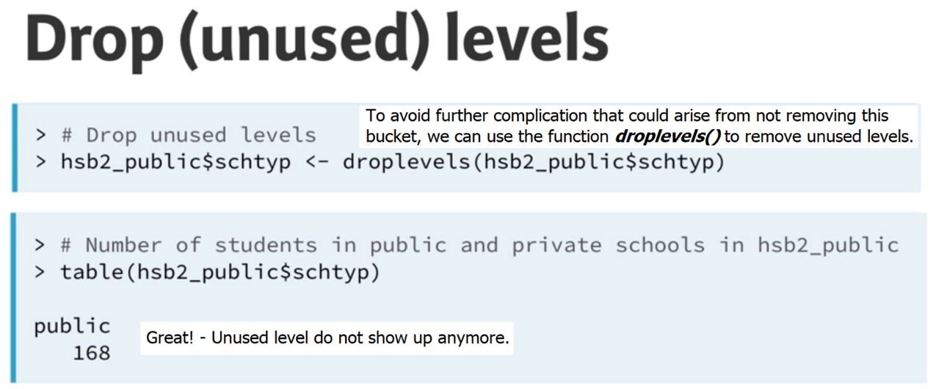

# Filtering based on a factor

Categorical data are often stored as factors in R. In this exercise, we'll practice working with a factor variable, number, from the email50 dataset. This variable tells us what type of number (none, small, or big) an email contains.

Recall from the video that the filter() function from dplyr can be used to filter a dataset to create a subset containing only certain levels of a variable. For example, the following code filters the mtcars dataset for cars containing 6 cylinders:

mtcars %>%

filter(cyl == 6)

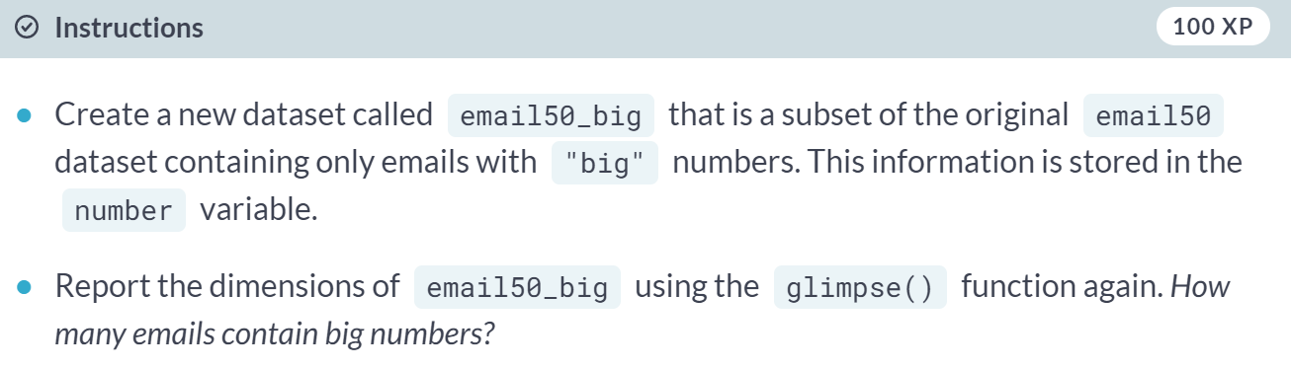

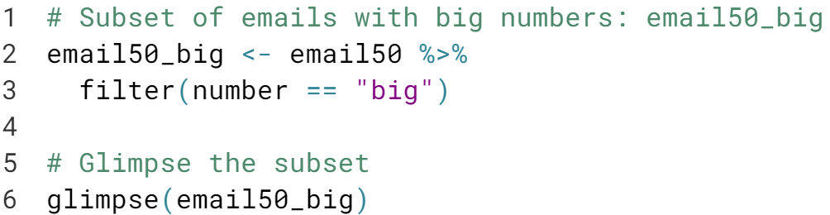

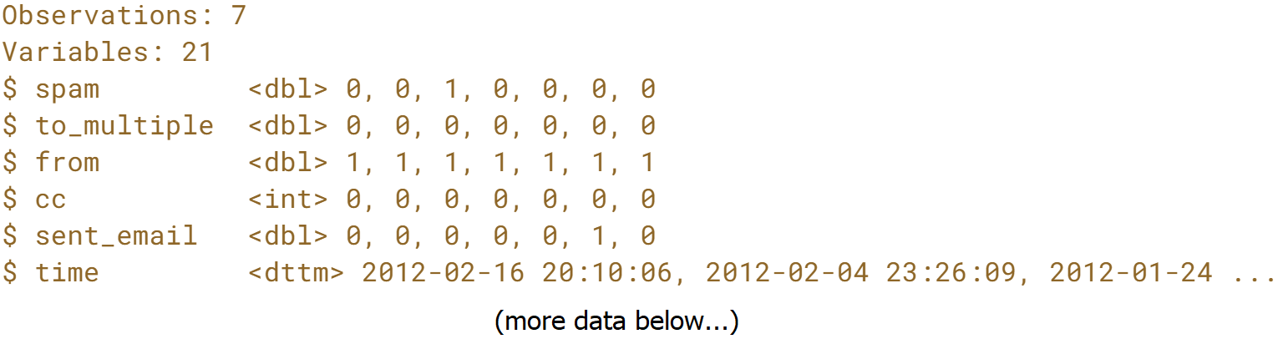

# Complete filtering based on a factor

The droplevels() function removes unused levels of factor variables from our dataset. As we saw in the video, it's often useful to determine which levels are unused (i.e. contain zero values) with the table() function.

In this exercise, we'll see which levels of the number variable are dropped after applying the droplevels() function.

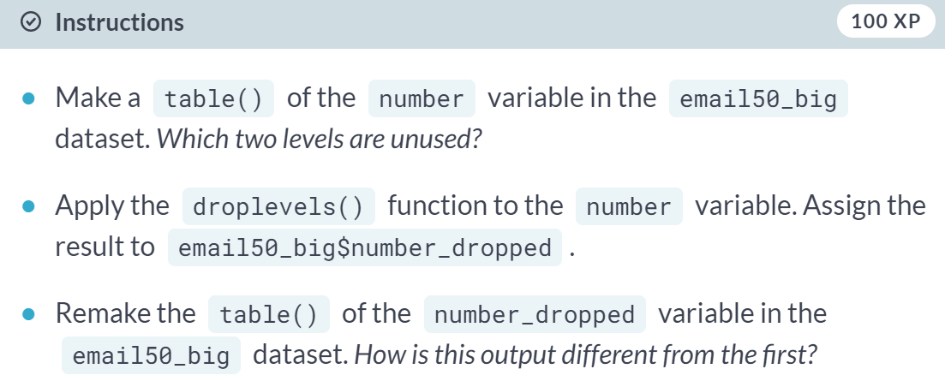

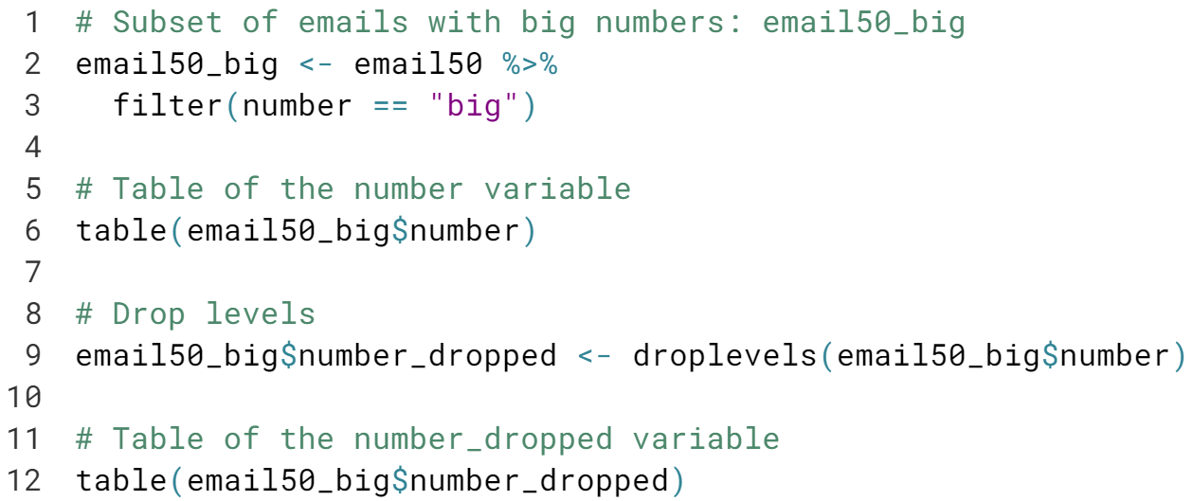

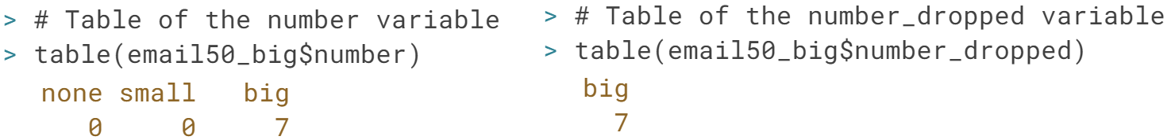  
Did you notice that dropping the levels of the number variable gets rid of the levels with counts of zero? This will be useful when you're creating visualizations later on. Great work!



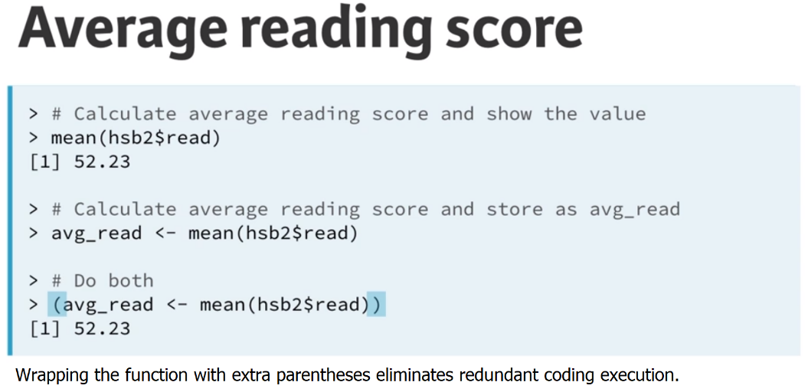  
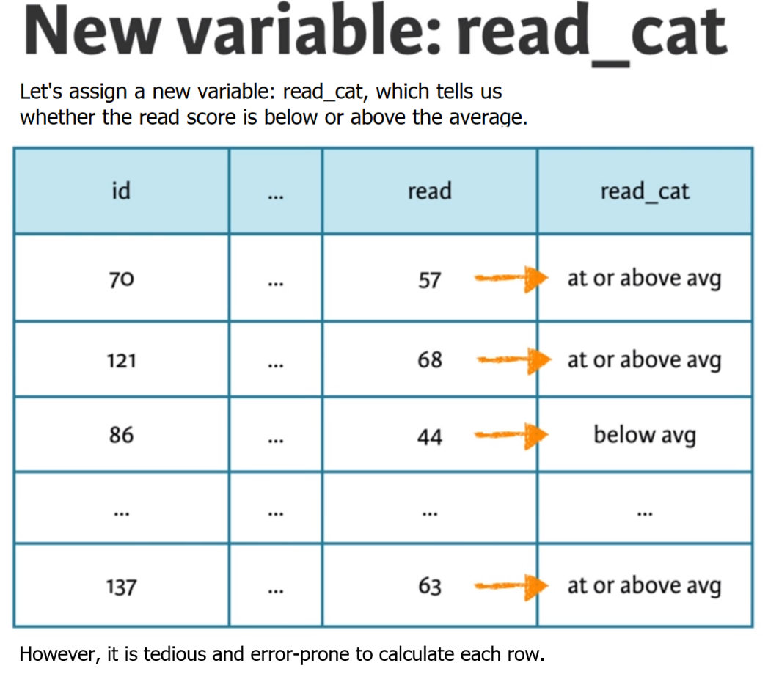  
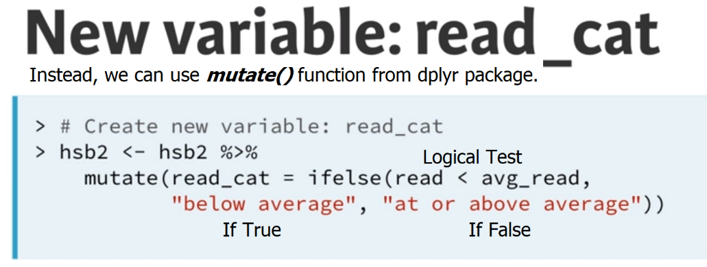



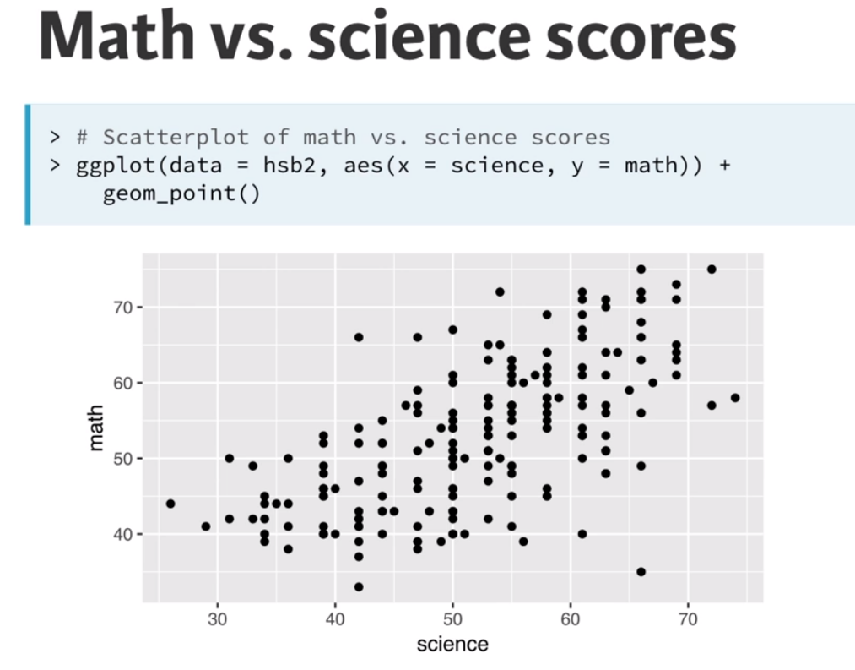

There is a positive correlation between the math scores and science scores.

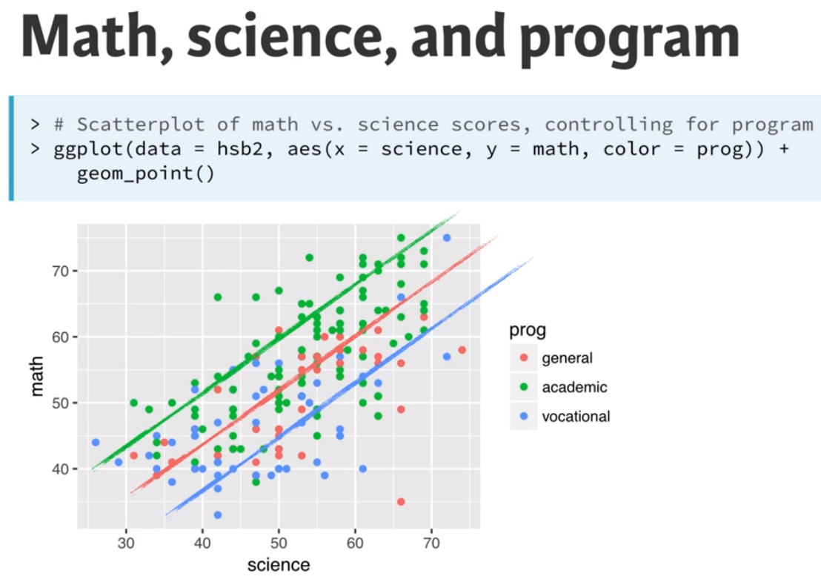  
From this multivariable plot, we can infer that students from academic program tend to do better than the students from other programs.

# Discretize a different variable

In this exercise, we'll create a categorical version of the num_char variable in the email50 dataset. num_char is the number of characters in an email, in thousands. This new variable will have two levels ("below median" and "at or above median") depending on whether an email has less than the median number of characters or equal to or more than that value.

The median marks the 50th percentile, or midpoint, of a distribution, so half of the emails should fall in one category and the other half in the other. You will learn more about the median and other measures of center in the next course in this series.

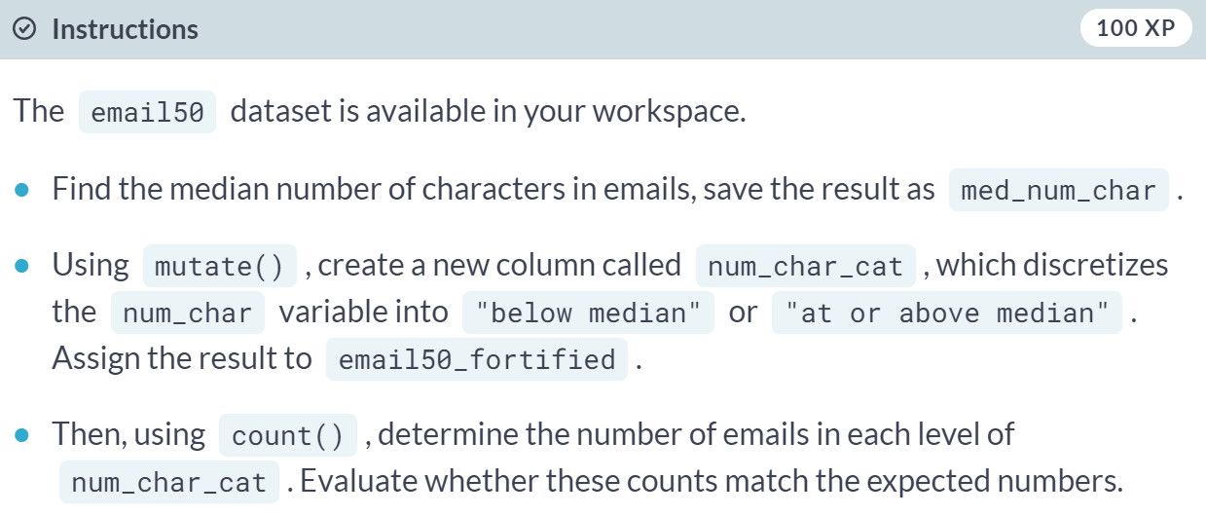  
  
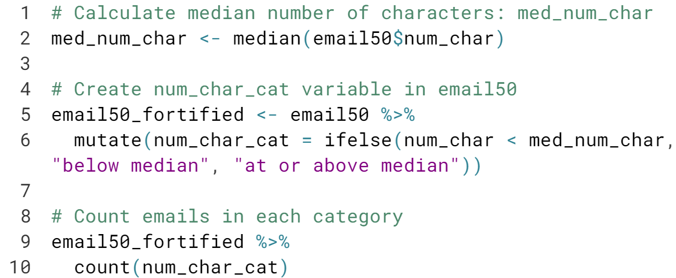  
  
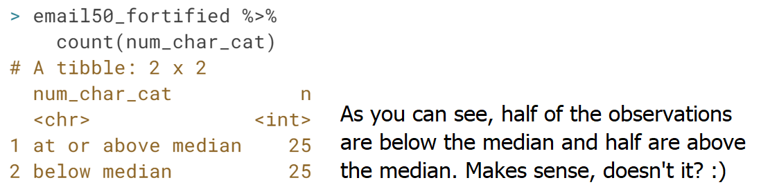

# Combining levels of a different factor

Another common way of creating a new variable based on an existing one is by combining levels of a categorical variable. For example, the email50 dataset has a categorical variable called number with levels "none", "small", and "big", but suppose we're only interested in whether an email contains a number. In this exercise, we will create a variable containing this information and also visualize it.

For now, do your best to understand the code we've provided to generate the plot. We will go through it in detail in the next video.

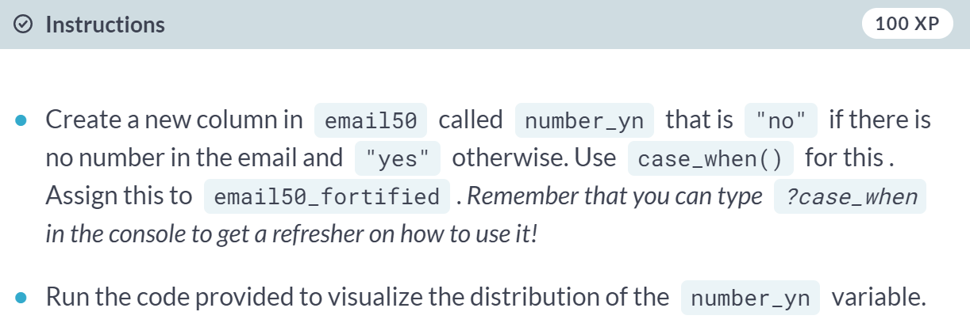

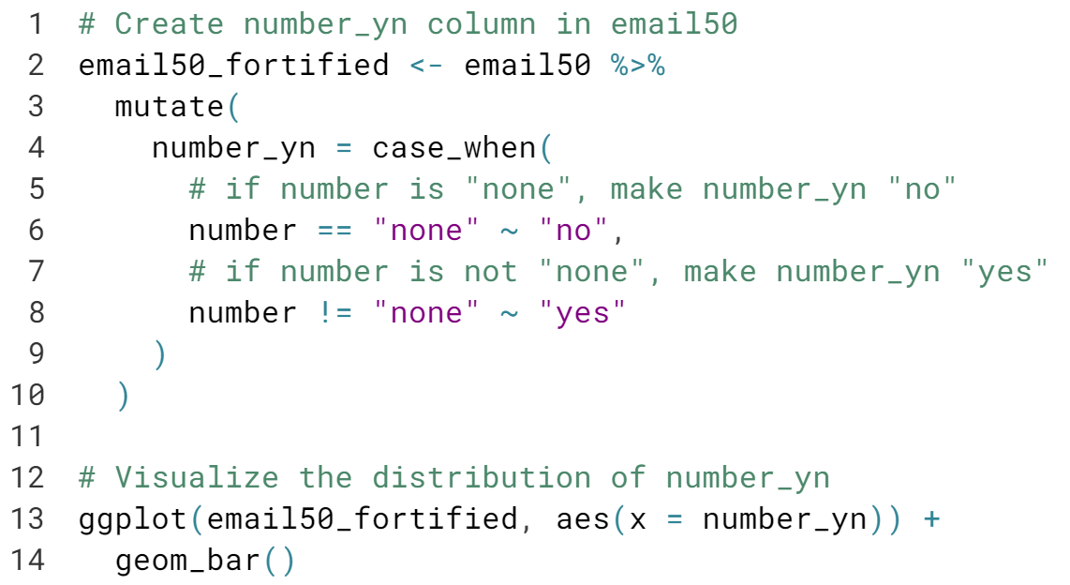  
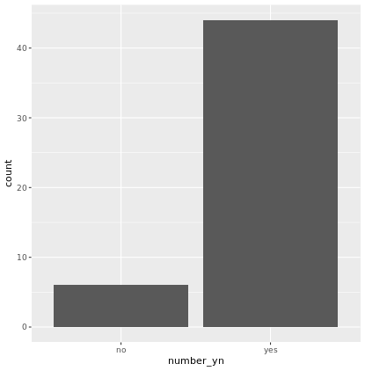

# Visualizing numerical and categorical data

In this exercise, we'll visualize the relationship between two numerical variables from the email50 dataset, conditioned on whether or not the email was spam. This means that we will use an aspect of the plot (like color or shape) to identify the levels in the spam variable so that we can compare plotted values between them.

Recall that in the ggplot() function, the first argument is the dataset, then we map the aesthetic features of the plot to variables in the dataset, and finally the geom_*() layer informs how data are represented on the plot. In this exercise, we will make a scatterplot by adding a geom_point() layer to the ggplot() call.

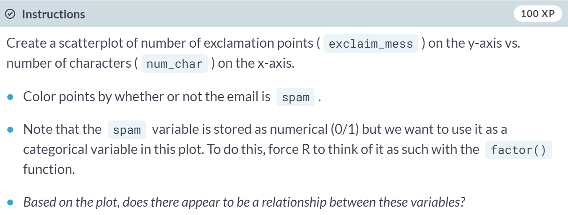  
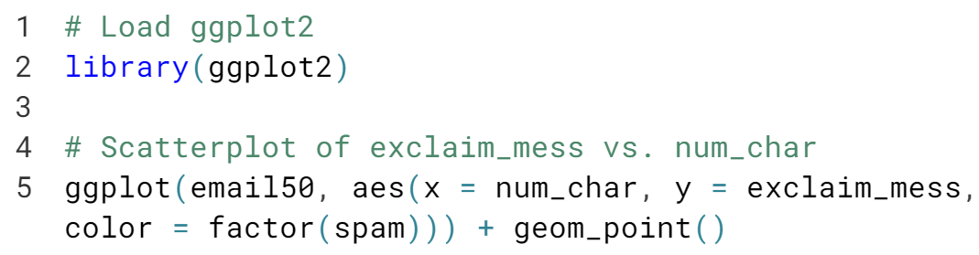  
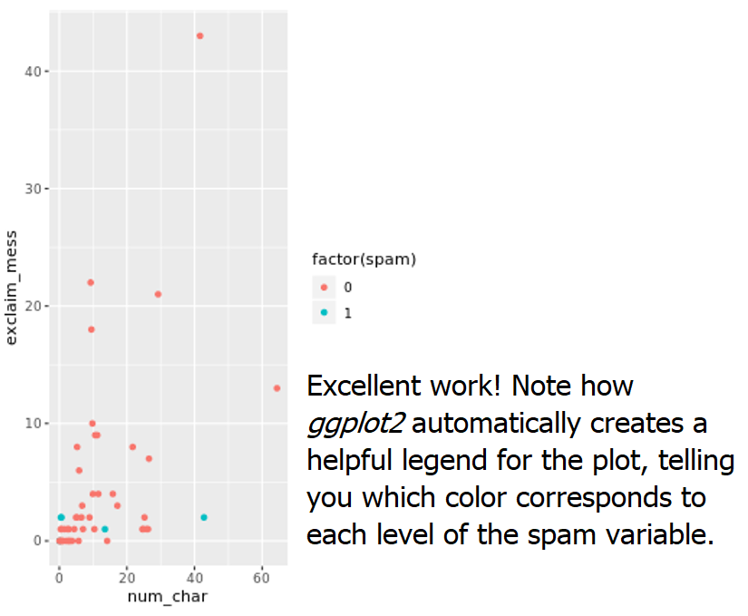

**Study types and cautionary tales**In this chapter, we will learn about observational studies and experiments, scope of inference, and Simpson's paradox.



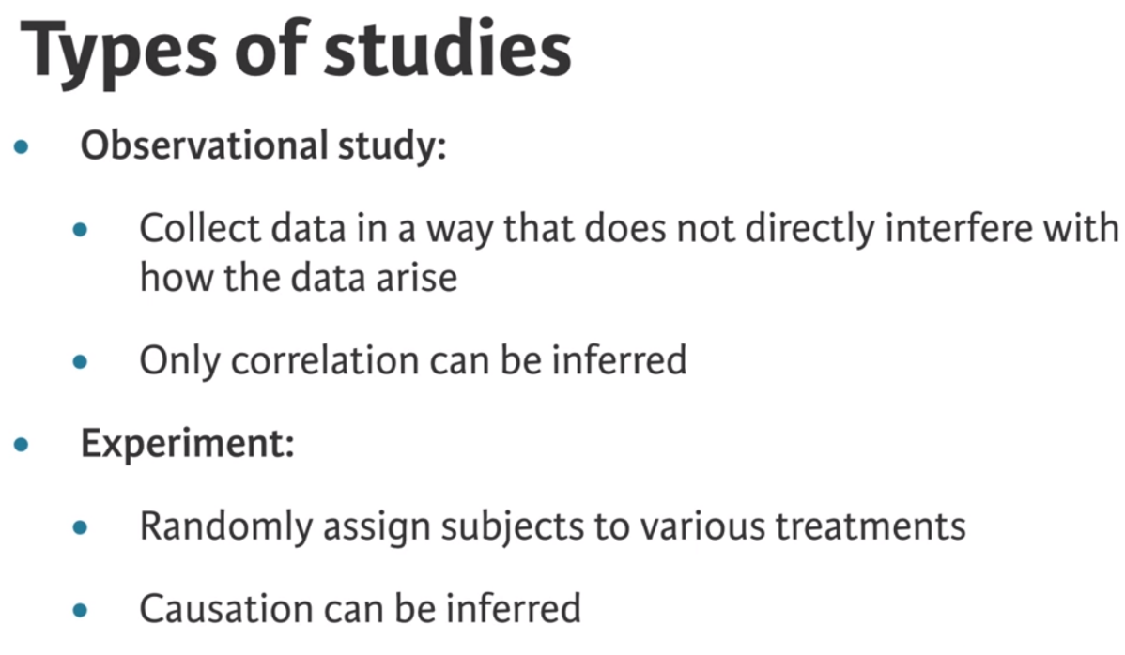  
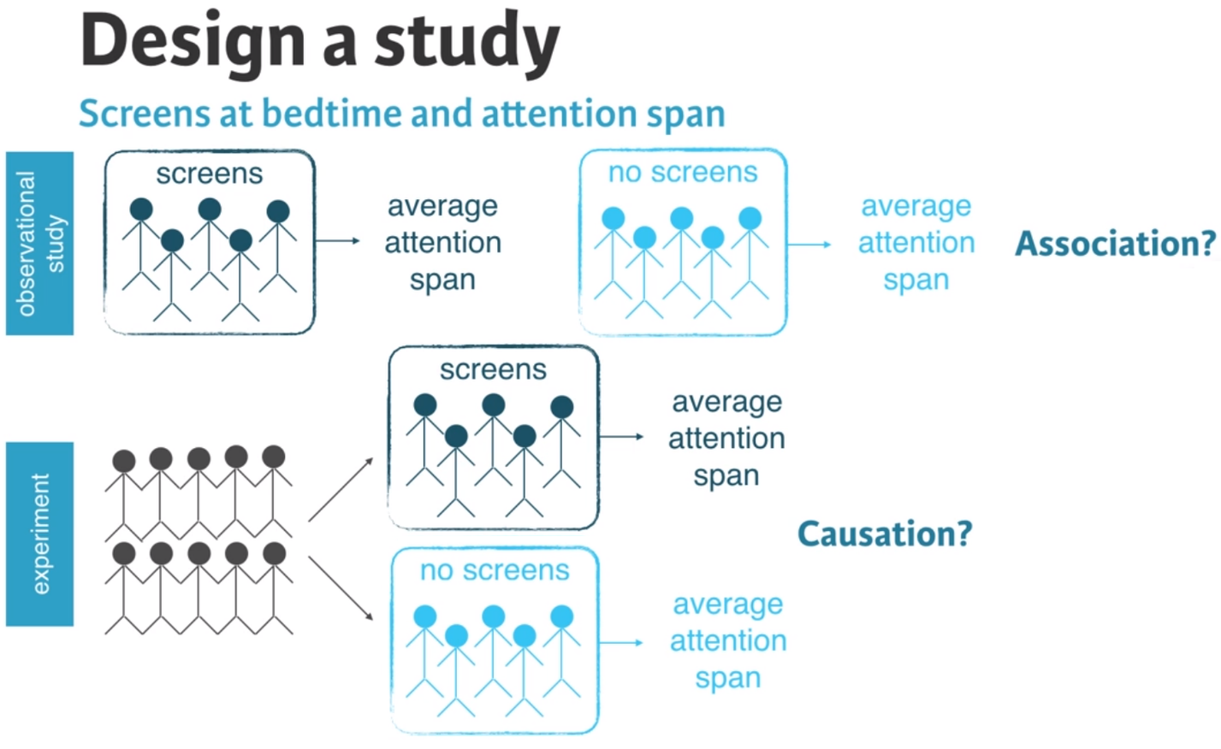

# Identify type of study: Reading speed and font

A study is designed to evaluate whether people read text faster in Arial or Helvetica font. A group of volunteers who agreed to be a part of the study are randomly assigned to two groups: one where they read some text in Arial, and another where they read the same text in Helvetica. At the end, average reading speeds from the two groups are compared.

What type of study is this?

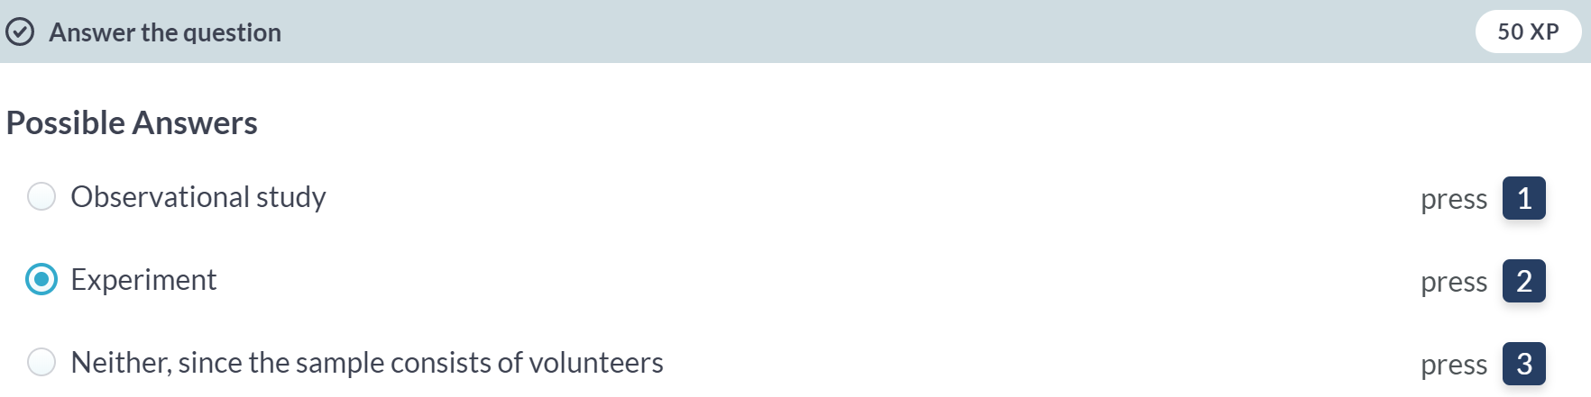  
Awesome! Even though participants are volunteers, this is still an experiment!

# Identify type of study: Countries

Next, let's take a look at data from a different study on country characteristics. First, load the data and view it, then identify the type of study. Remember, an experiment requires random assignment.

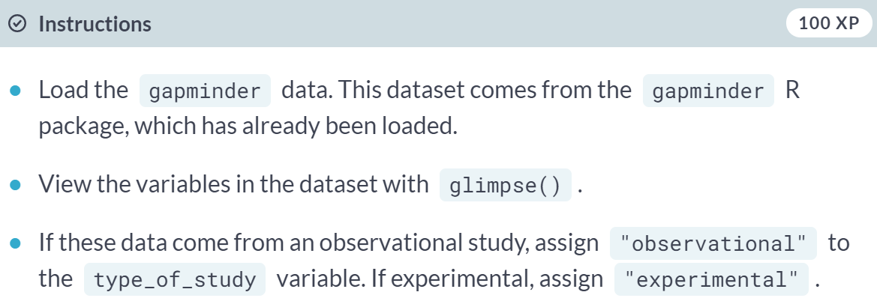

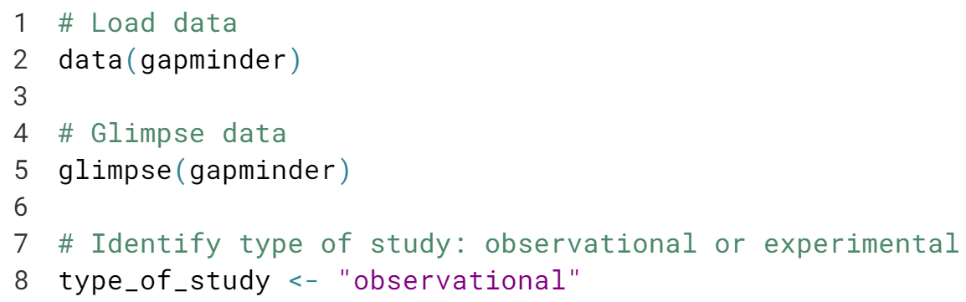

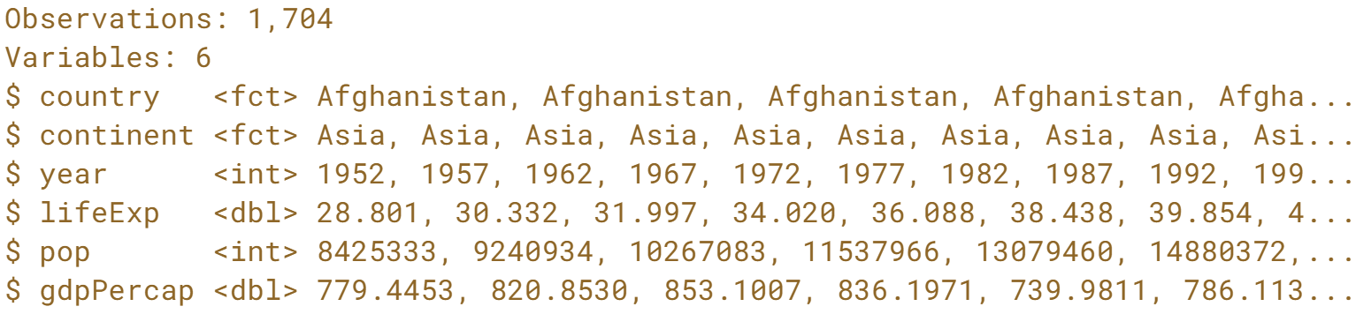  
Right! Since there is no way to randomly assign countries to attributes, this is an observational study. Nice work!

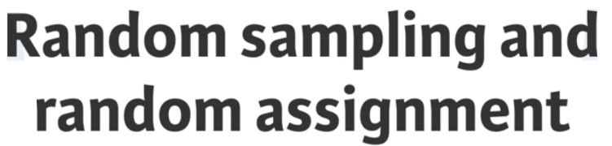

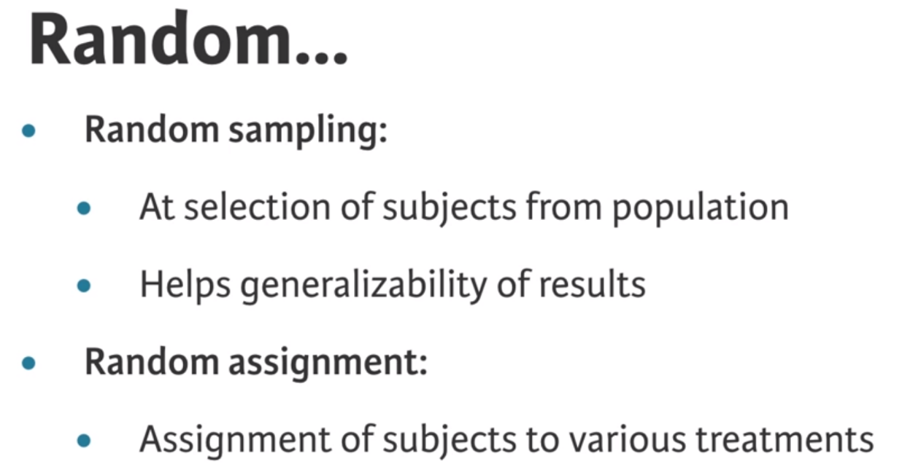

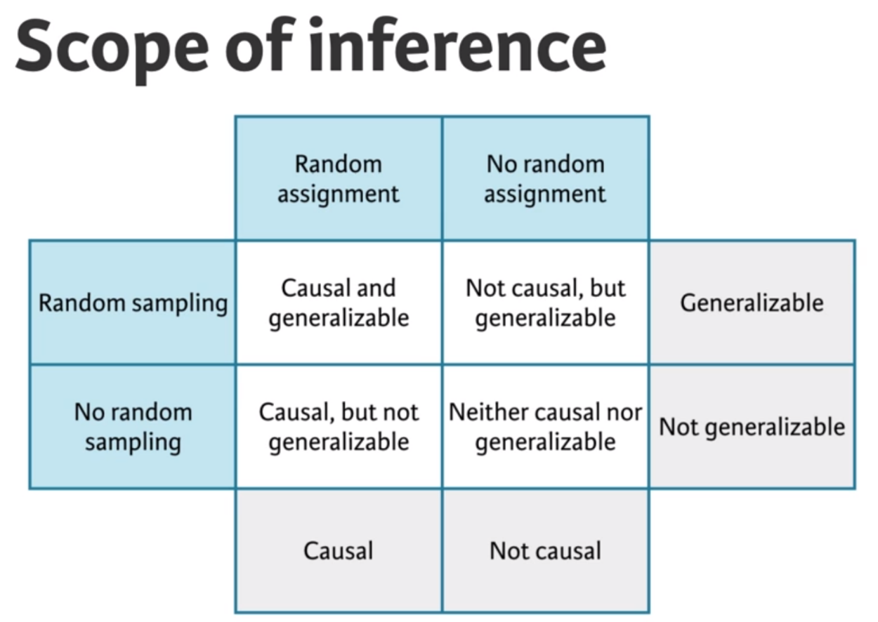

# Random sampling or random assignment?

One of the early studies linking smoking and lung cancer compared patients who are already hospitalized with lung cancer to similar patients without lung cancer (hospitalized for other reasons) and recorded whether each patient smoked. Then, proportions of smokers for patients with and without lung cancer were compared.

Does this study employ random sampling and/or random assignment?

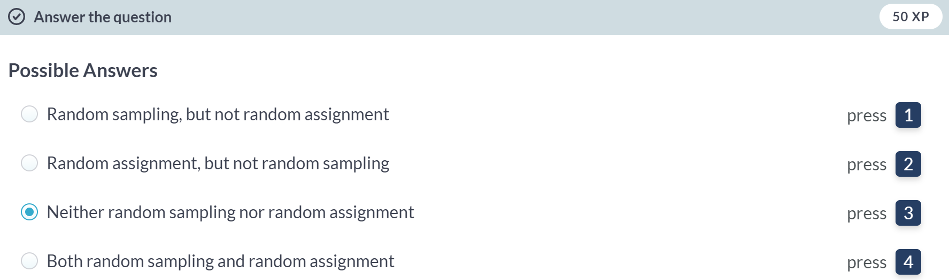

Right! Random assignment failed to be employed because the conditions are not imposed on the patients by the people conducting the study; random sampling also failed to be employed because the study records the patients who are already hospitalized, so it wouldn't be appropriate to apply the findings back to the population as a whole.

# Identify the scope of inference of study

Volunteers were recruited to participate in a study where they were asked to type 40 bits of trivia—for example, "an ostrich’s eye is bigger than its brain"—into a computer.

A randomly selected half of these subjects were told the information would be saved in the computer; the other half were told the items they typed would be erased.

Then, the subjects were asked to remember these bits of trivia, and the number of bits of trivia each subject could correctly recall were recorded. It was found that the subjects were significantly more likely to remember information if they thought they would not be able to find it later.

The results of the study ___ be generalized to all people and a causal link between believing information is stored and memory ___ be inferred based on these results.

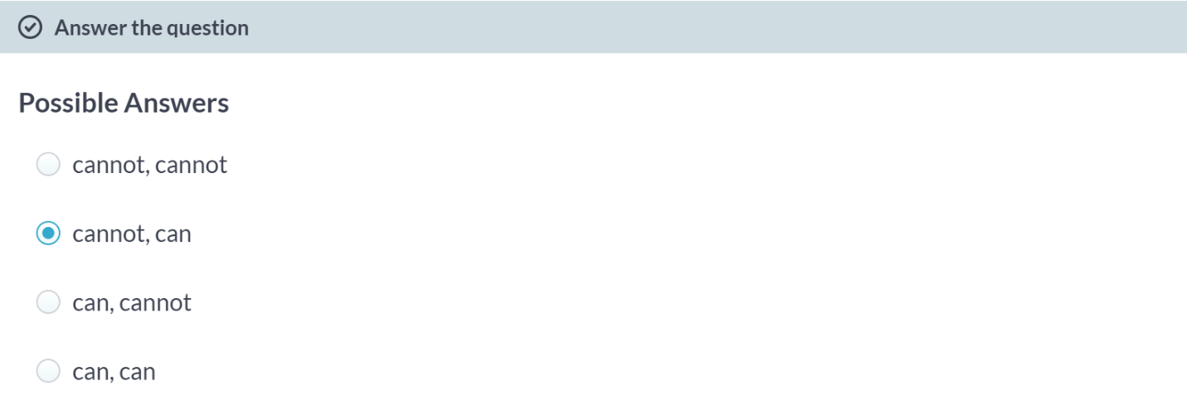  
  
Correct! There is no random sampling since the subjects of the study were volunteers, so the results cannot be generalized to all people.

However, due to random assignment, we are able to infer a causal link between the belief information is stored and the ability to recall that same information.



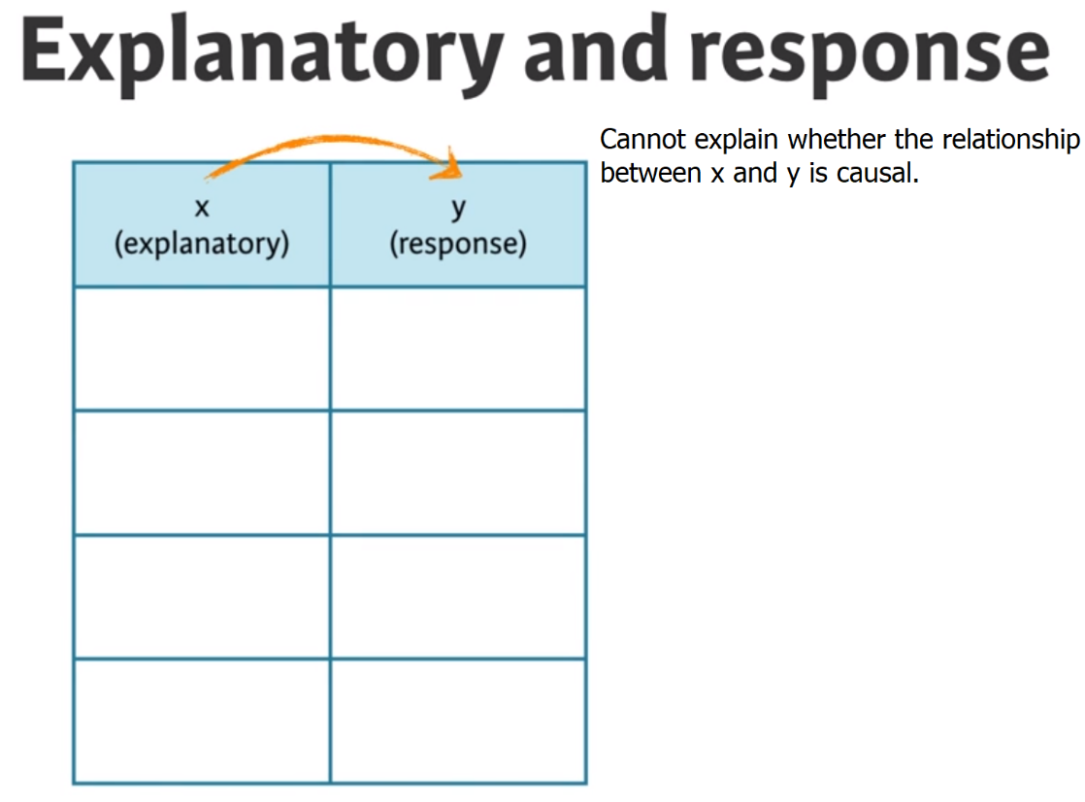  
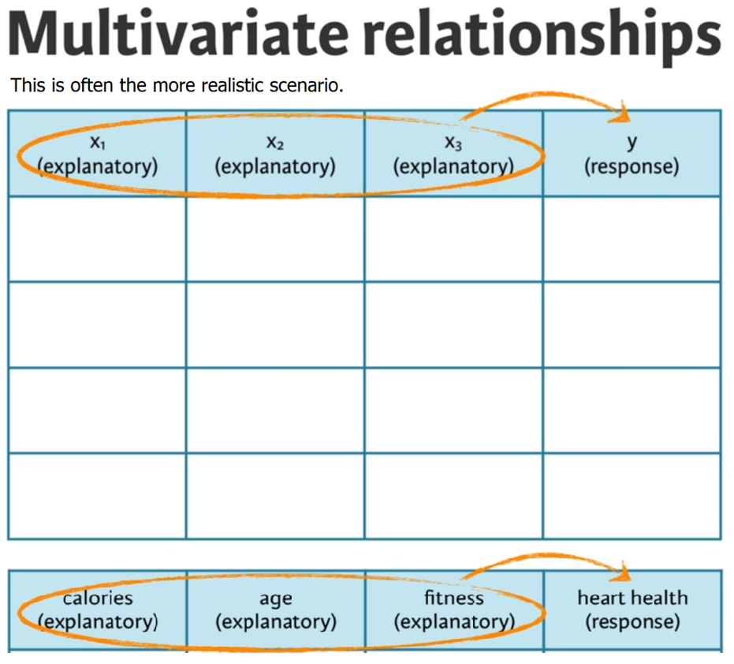

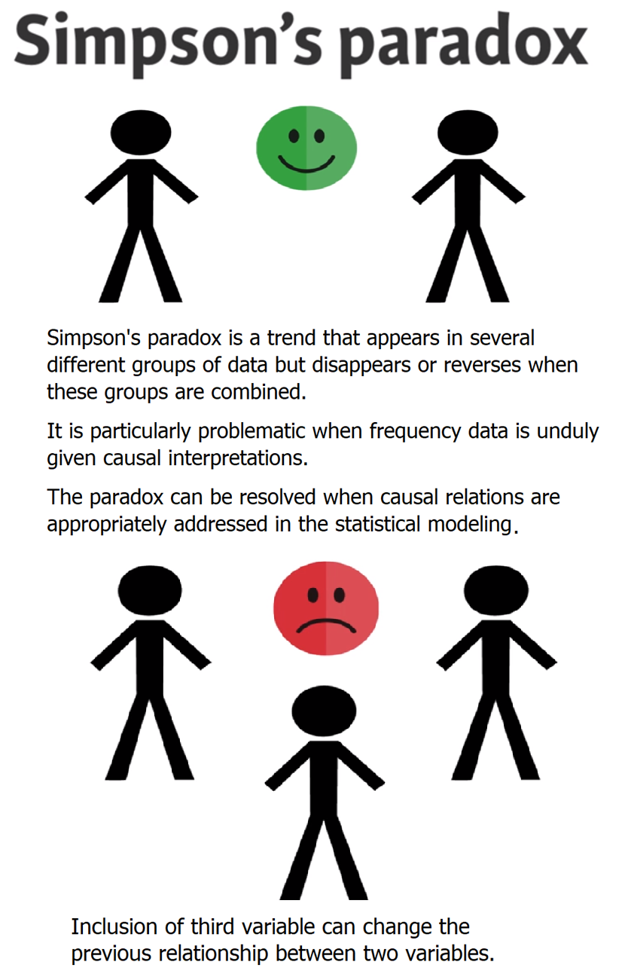

# Number of males and females admitted

The goal of this exercise is to determine the numbers of male and female applicants who got admitted and rejected. Specifically, we want to find out how many males are admitted and how many are rejected. And similarly we want to find how many females are admitted and how many are rejected.

To do so we will use the count() function from the dplyr package.

In one step, [**count()**](https://www.rdocumentation.org/packages/dplyr/topics/tally) groups the data and then tallies the number of observations in each level of the grouping variable. These counts are available under a new variable called n.

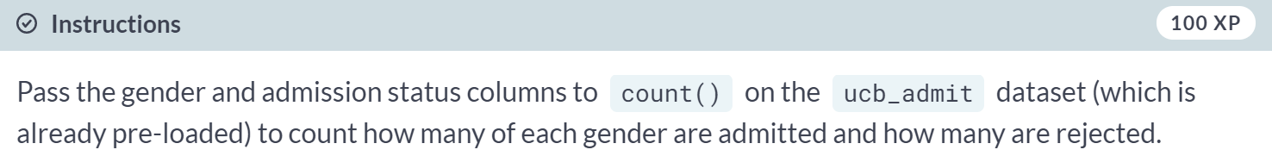

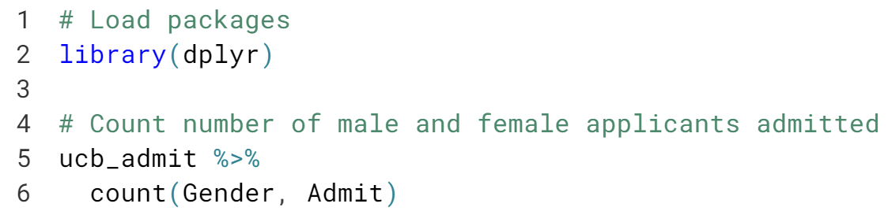

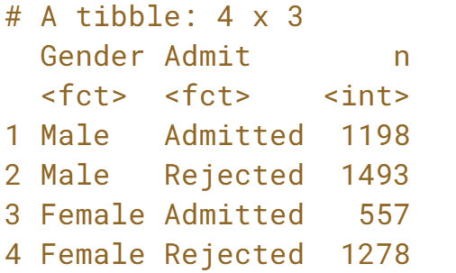

Cool counting! Passing several arguments to ***count()*** gives you the number of rows for each combination of those arguments.

# Proportion of males admitted overall

Next we'll calculate the percentage of males and percentage of females admitted, by creating a new variable, called prop (short for proportion) based off of the counts calculated in the previous exercise and using the mutate() from the dplyr package.

Proportions for each row of the data frame we created in the previous exercise can be calculated as n / sum(n). Note that since the data are grouped by gender, sum(n) will be calculated for males and females separately.

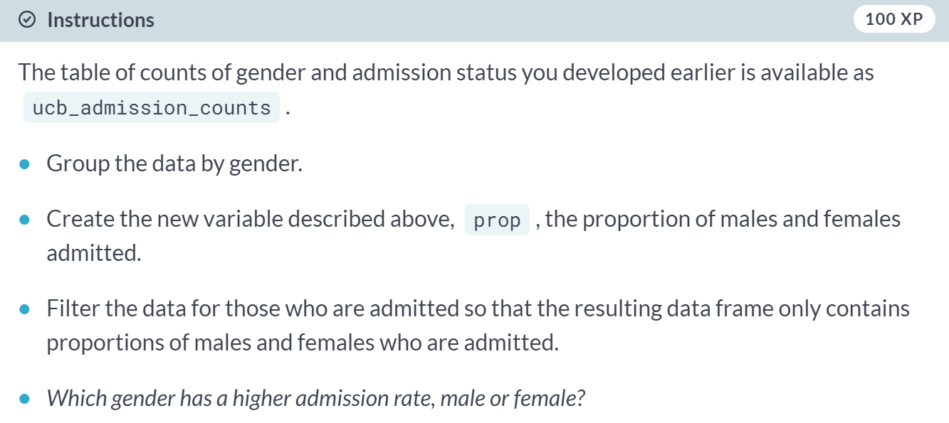

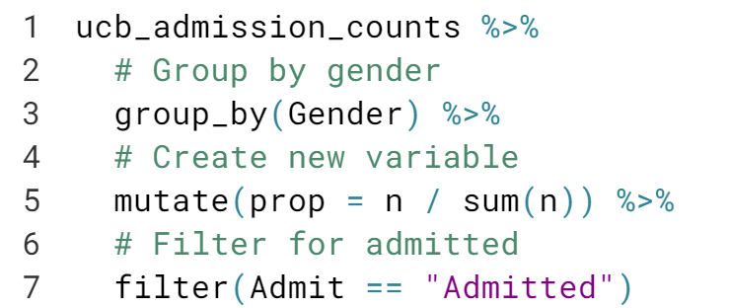  
  
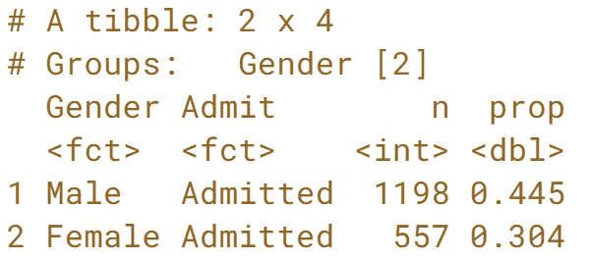  
Fantastic! It looks like 44% of males were admitted versus only 30% of females, but as you'll see in the next exercise, there's more to the story.

# Proportion of males admitted for each department

Finally we'll make a table similar to the one we constructed earlier, except we'll first group the data by department. The goal is to compare the proportions of male admitted students across departments.

Proportions for each row of the data frame we create can be calculated as n / sum(n). Note that since the data are grouped by department and gender, sum(n) will be calculated for males and females separately **for each department**.

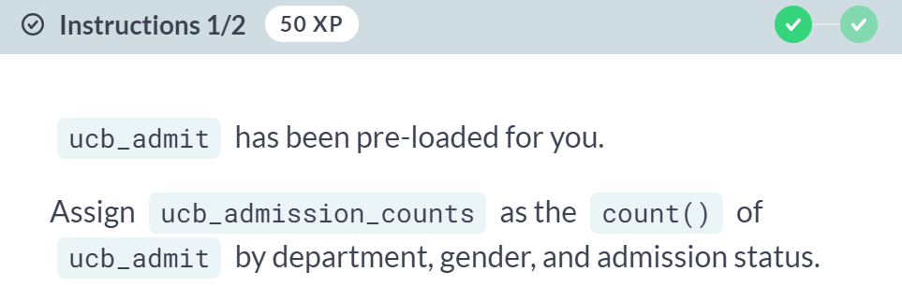

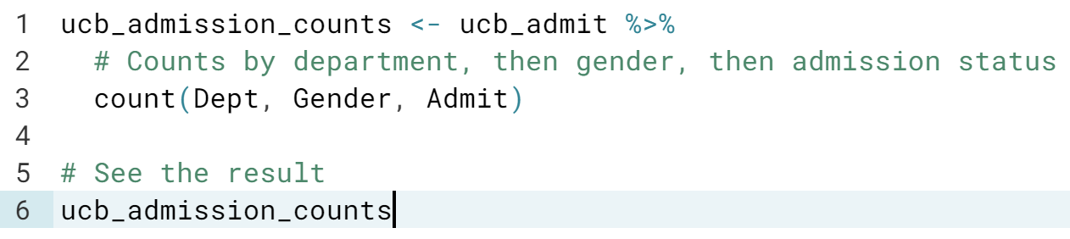

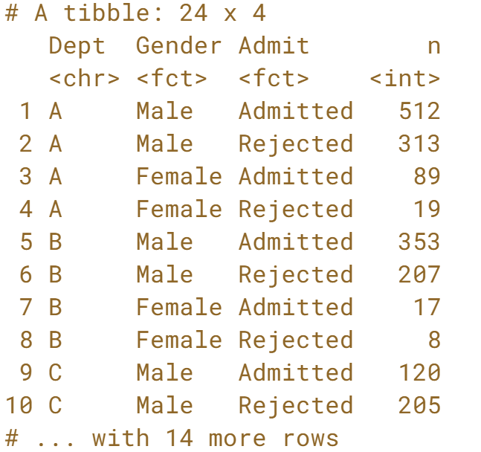

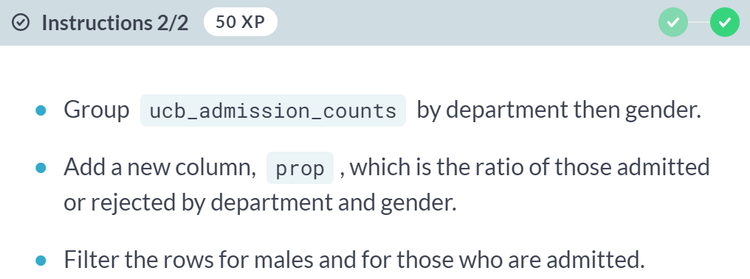

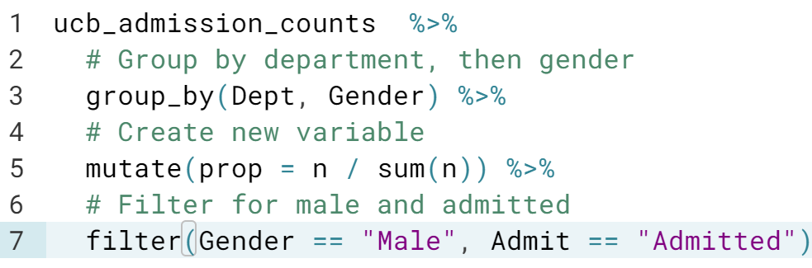

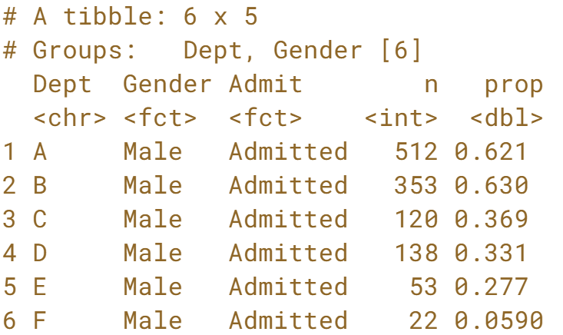

Amazing admission analyzing! The proportion of males admitted varies wildly between departments.

# Admission rates for males across departments

The final result from the previous exercise is available in your workspace as perc_admit_by_dept. Which of the following best describes the relationship between admission status and gender?

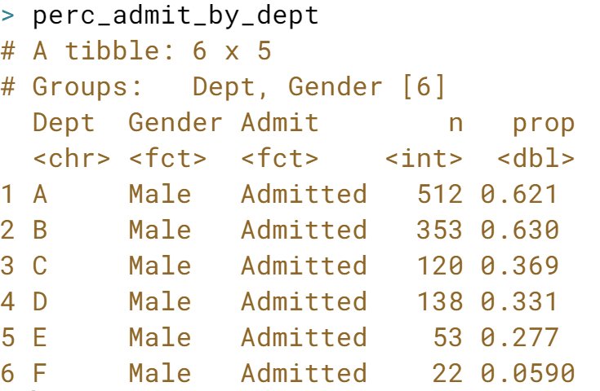

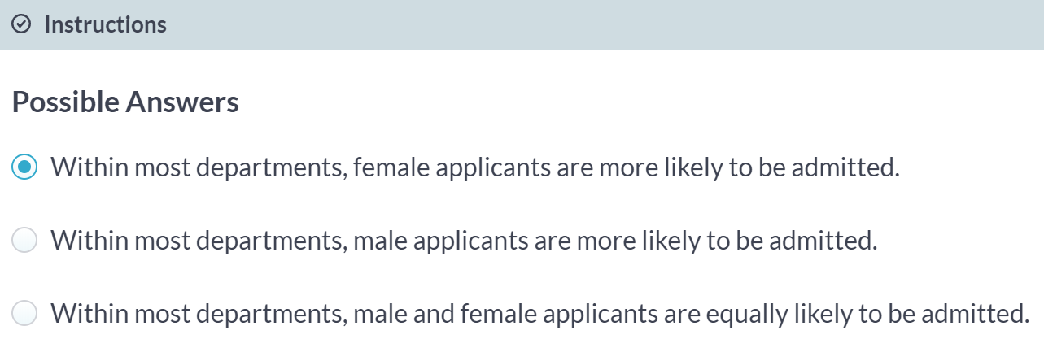



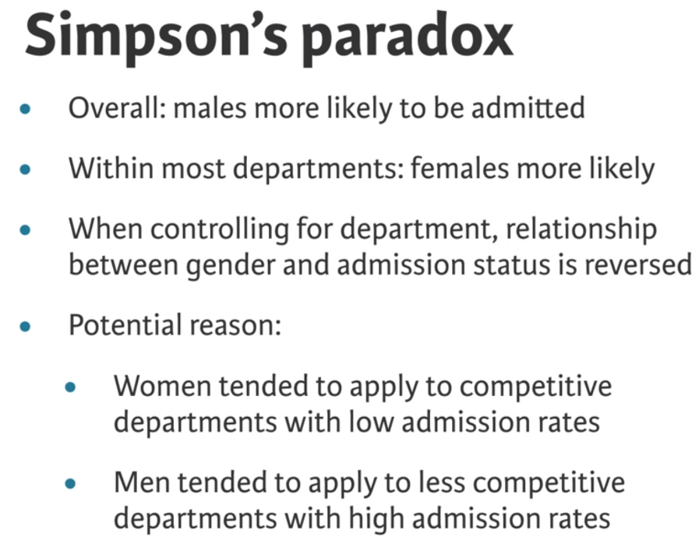

# Identify type of study: Countries [new]

Next, let's take a look at data from a different study on country characteristics. The data come from the gapminder R package. To view the top 10 rows of the data, simply type gapminder in the console. You are welcomed to view the data using other functionality we have learned so far as well.

Then, identify the type of study this data come from.

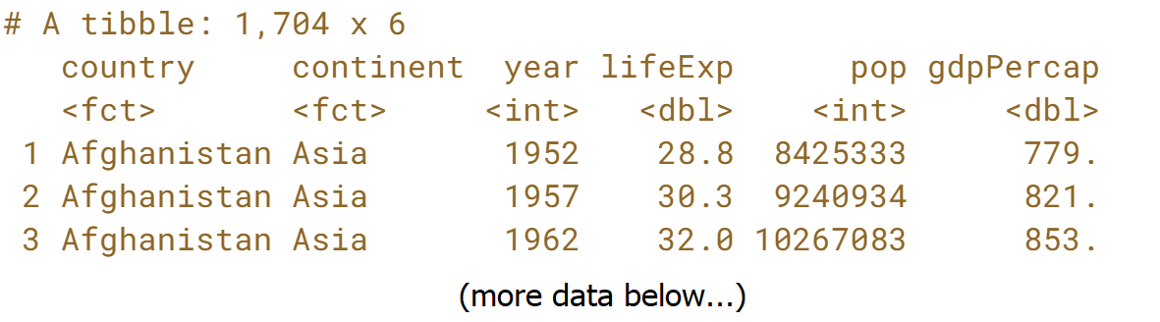  
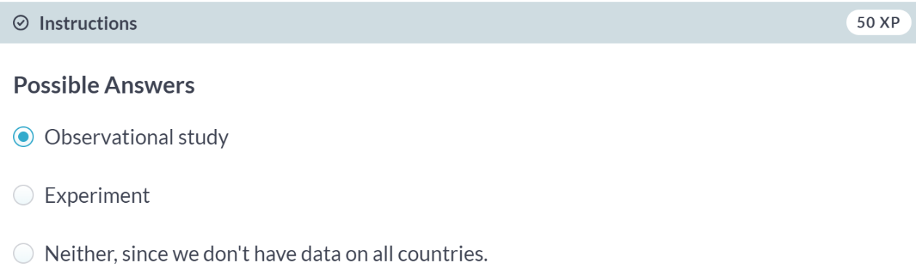

**Sampling strategies and experimental design**This chapter defines various sampling strategies and their benefits/drawbacks as well as principles of experimental design.



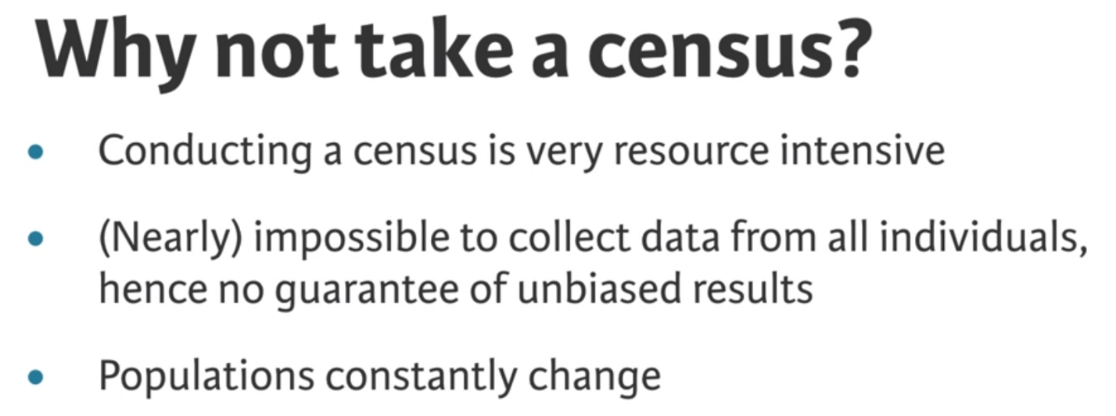

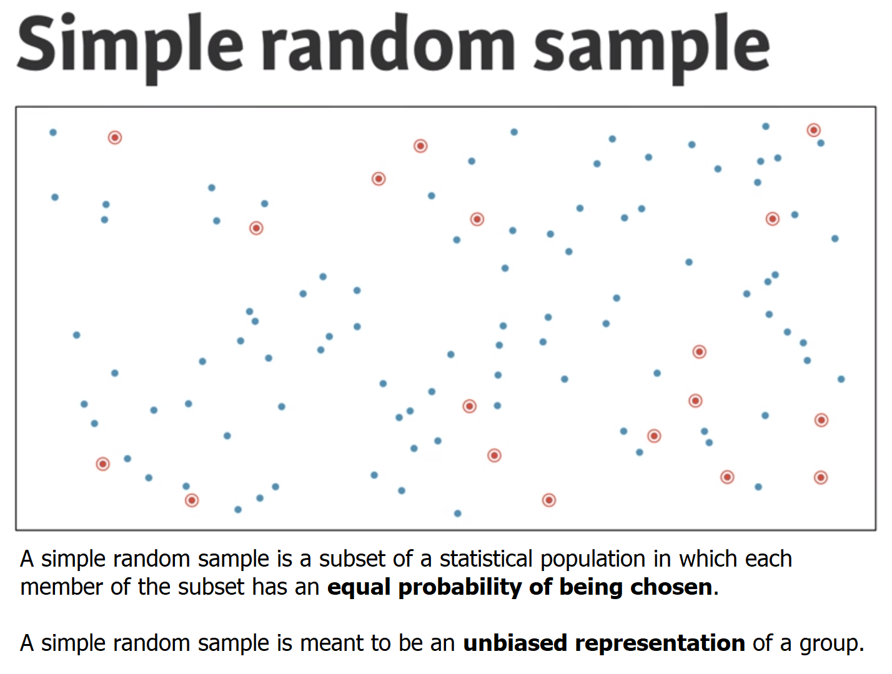

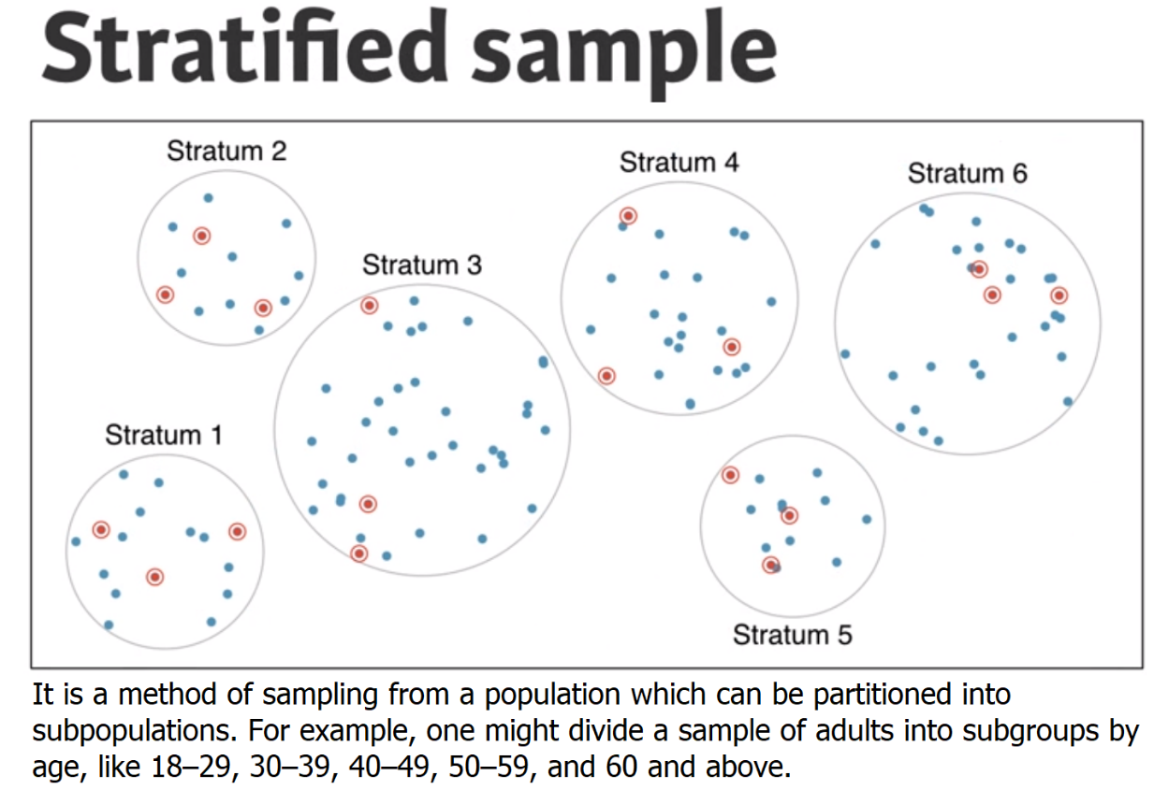

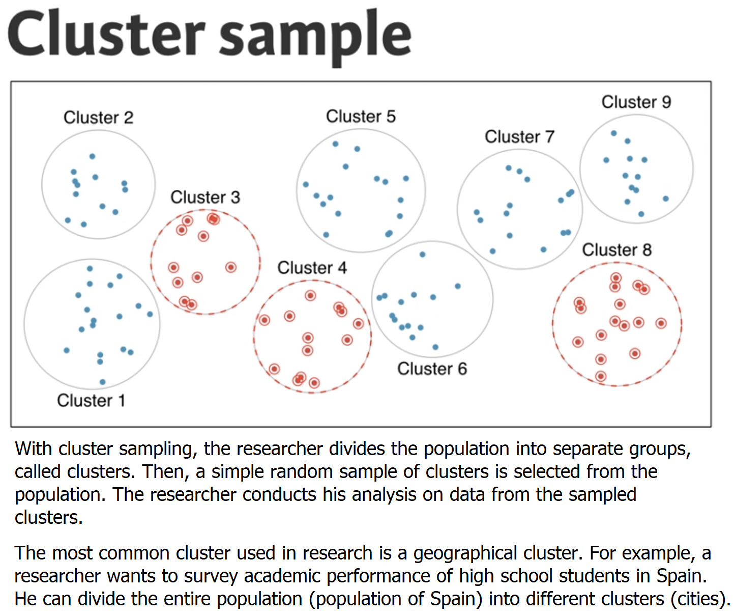

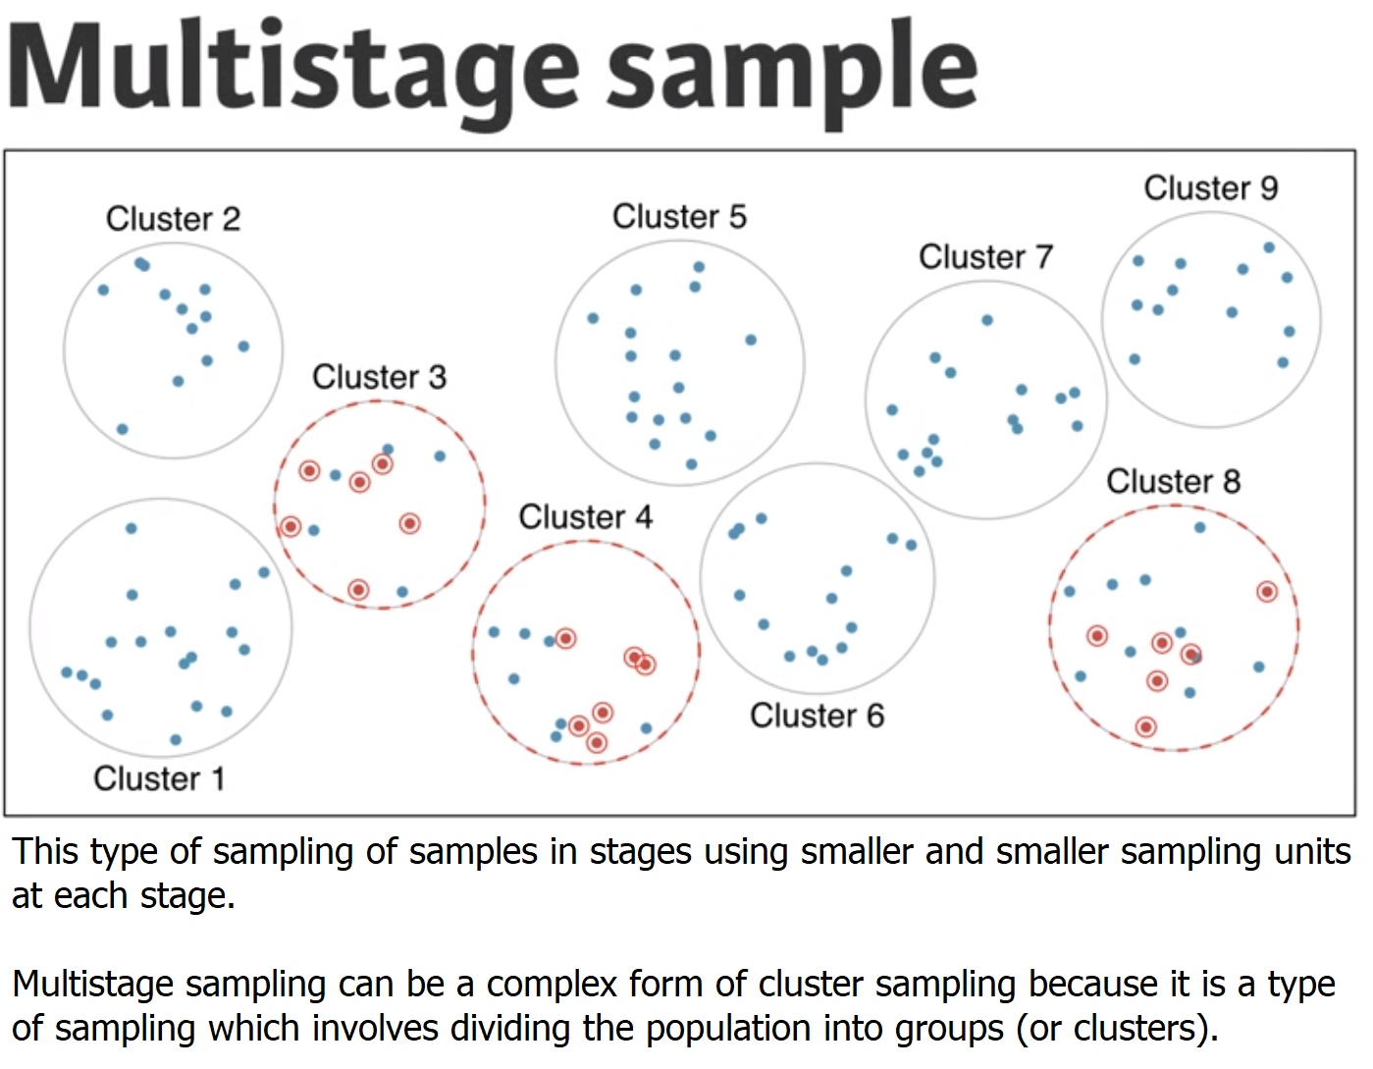

# Sampling strategies, determine which

A consulting company is planning a pilot study on marketing in Boston. They identify the zip codes that make up the greater Boston area, then sample 50 randomly selected addresses from each zip code and mail a coupon to these addresses. They then track whether the coupon was used in the following month.

What sampling strategy has this company used?  
  
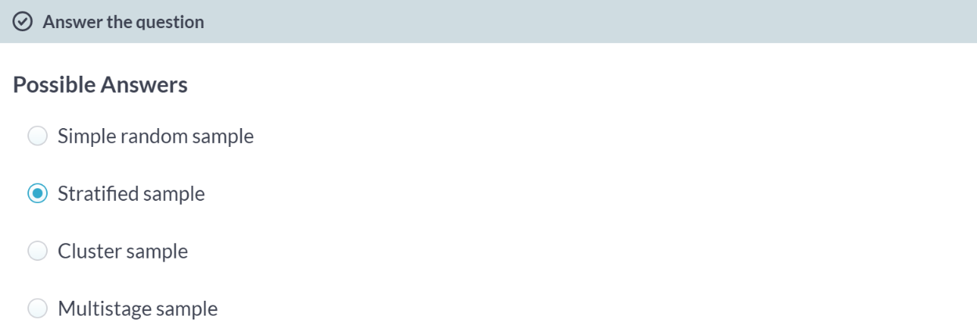

# Sampling strategies, choose worst

A school district has requested a survey be conducted on the socioeconomic status of their students. Their budget only allows them to conduct the survey in some of the schools, hence they need to first sample a few schools. Students living in this district generally attend a school in their neighborhood. The district is broken into many distinct and unique neighborhoods, some including large single-family homes and others with only low-income housing.

Which approach would likely be the **least effective** for selecting the schools where the survey will be conducted?

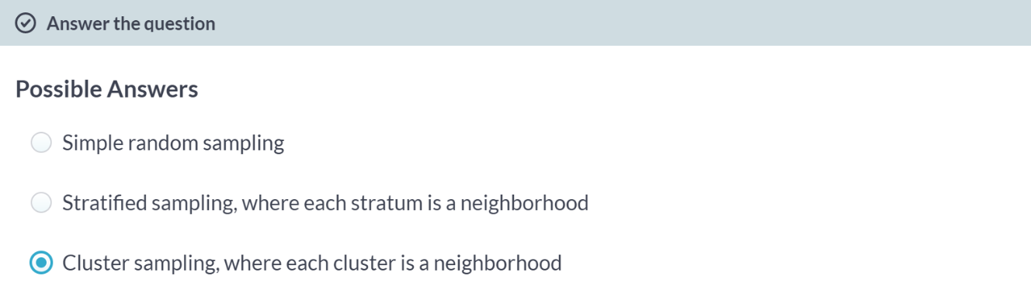  
Nice job! This sampling strategy would be a bad idea because each neighborhood has a unique socioeconomic status. A good study would collect information about every neighborhood.



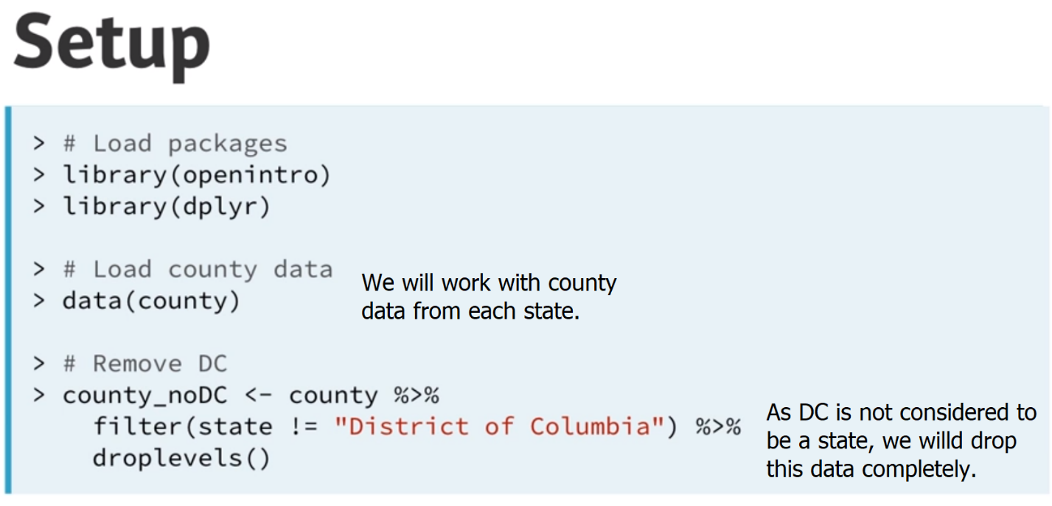

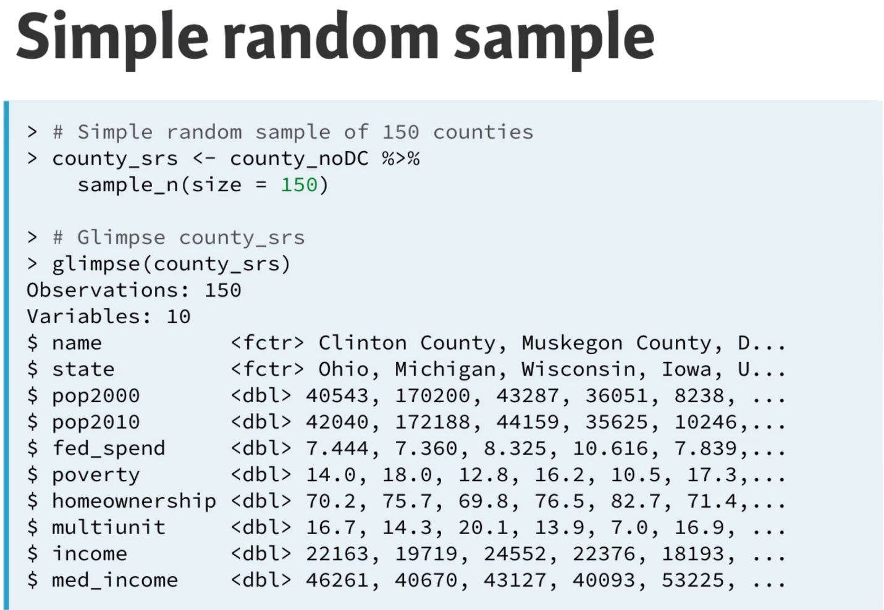

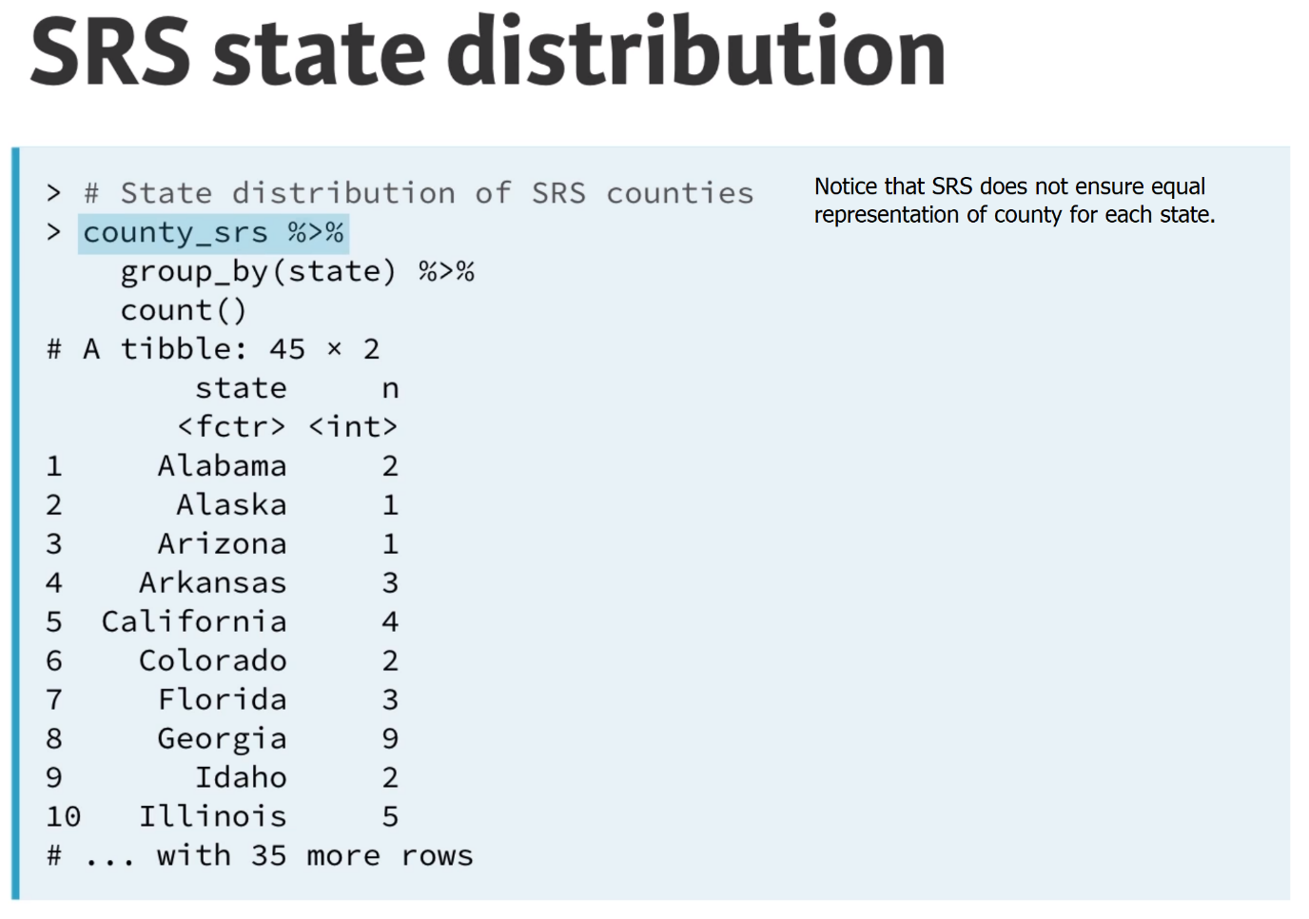  
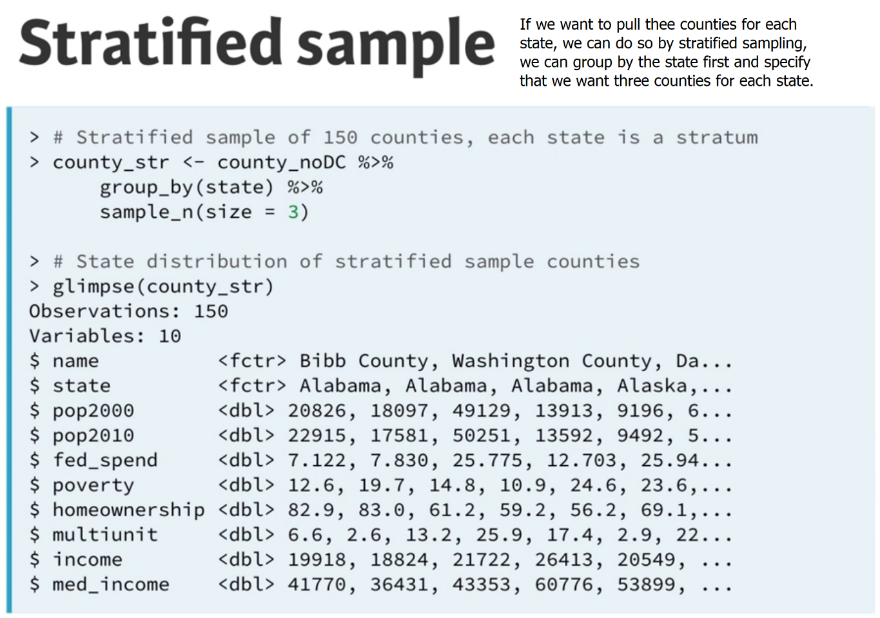

# Simple random sample in R

Suppose we want to collect some data from a sample of eight states. A list of all states and the region they belong to (Northeast, Midwest, South, West) are given in the us_regions data frame.

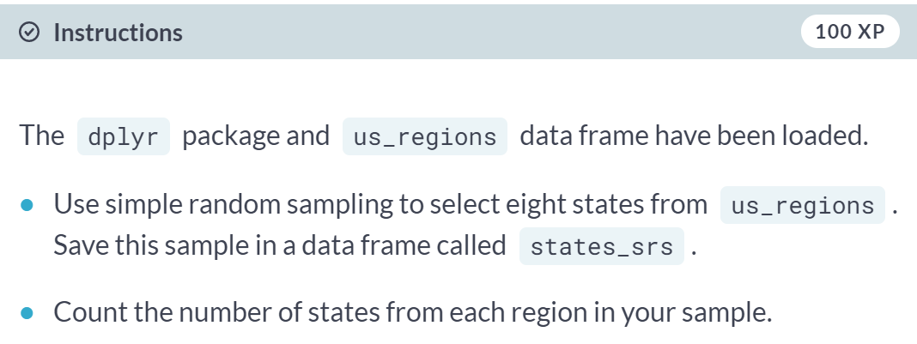

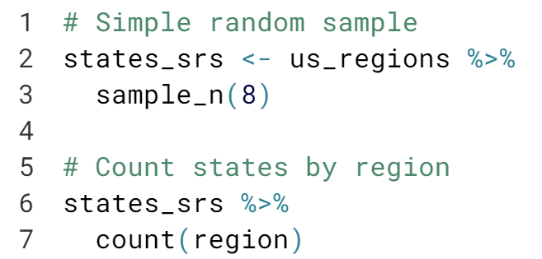

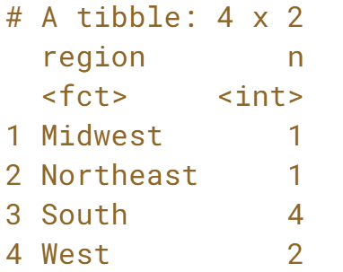  
Great work! Notice that this strategy may select an unequal number of states from each region. In the next exercise, you'll implement stratified sampling to be sure to select an equal number of states from each region.

# Stratified sample in R

In the previous exercise, we took a simple random sample of eight states. However, we did not have any control over how many states from each region got sampled. The goal of stratified sampling in this context is to have control over the number of states sampled from each region. Our goal for this exercise is to sample an equal number of states from each region.

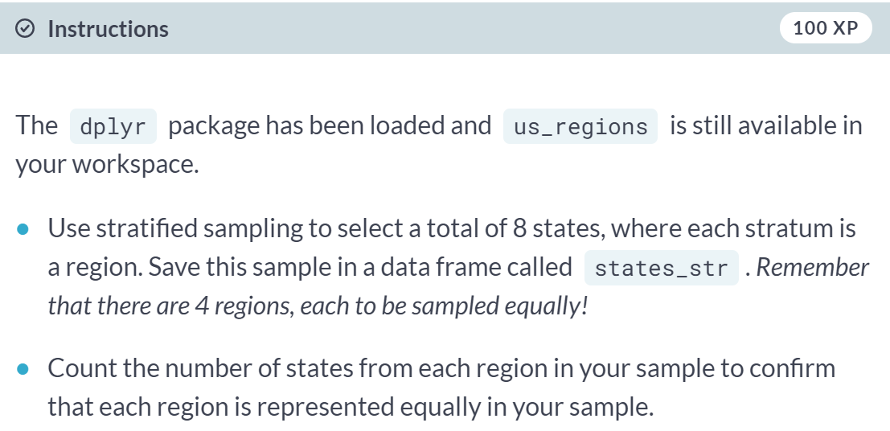

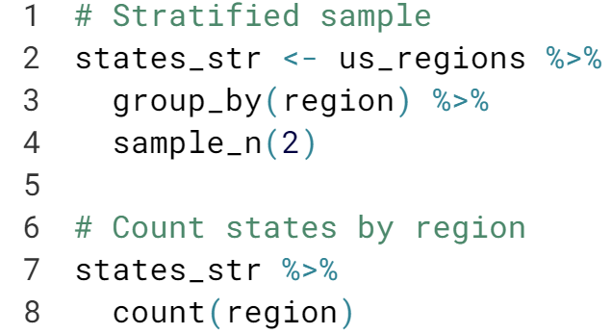

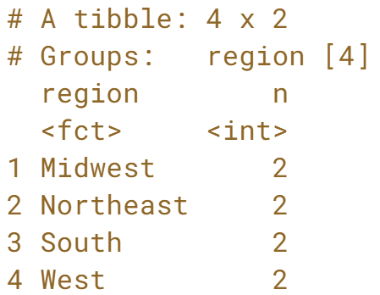  
Nice job! In this stratified sample, each stratum (i.e. Region) is represented equally.

# Compare SRS vs. stratified sample

Which method you implemented, simple random sampling or stratified sampling, ensured an equal number of states from each region?

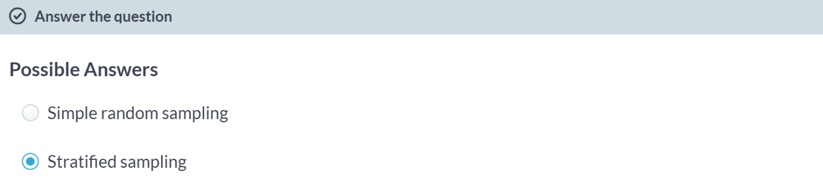

Super! Simple random sampling would result in different amounts of data being sampled from each state.



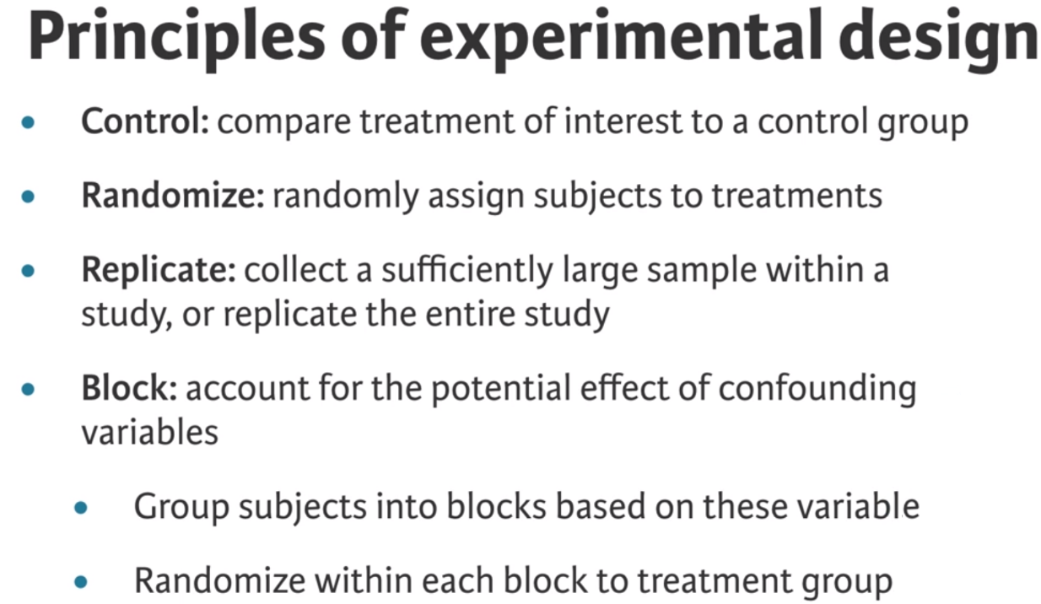  
  
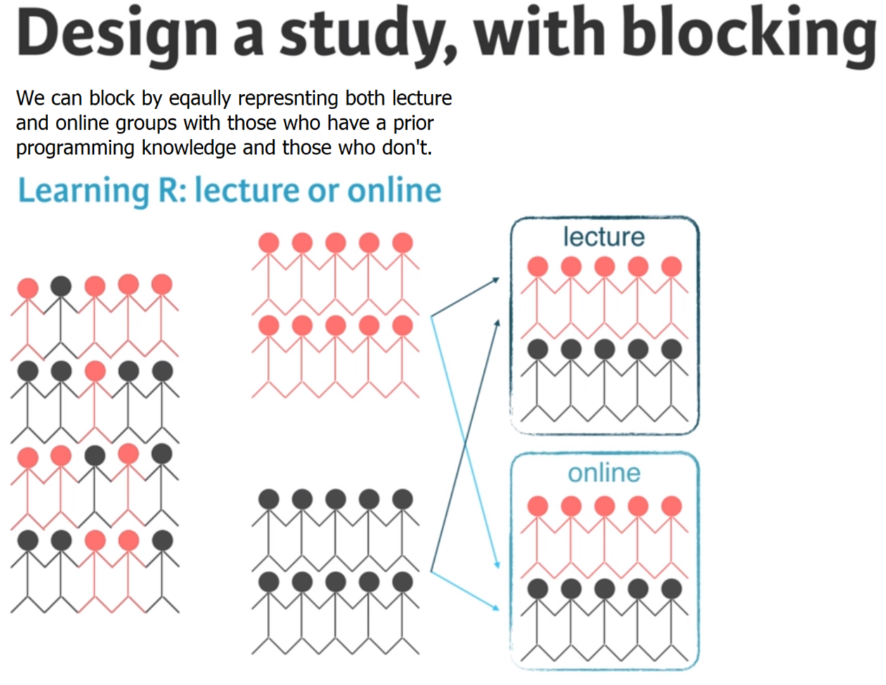

# Identifying components of a study

A researcher designs a study to test the effect of light and noise levels on exam performance of students. The researcher also believes that light and noise levels might have different effects on males and females, so she wants to make sure both genders are represented equally under different conditions.

Which of the below is correct?

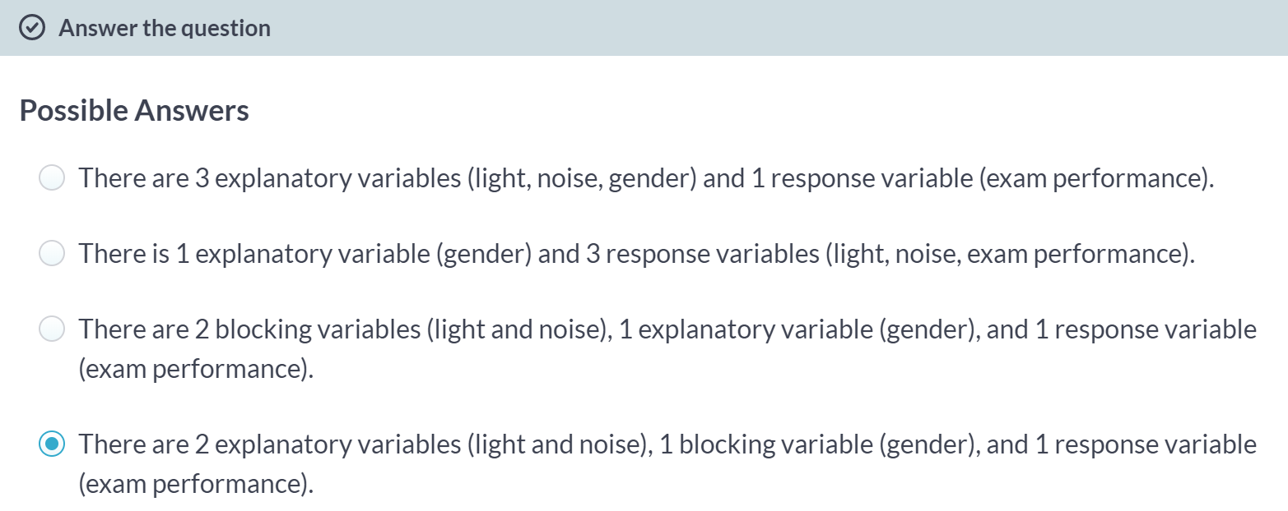

# Experimental design terminology

___ variables are conditions you can impose on the experimental units, while ___ variables are characteristics that the experimental units come with that you would like to control for.

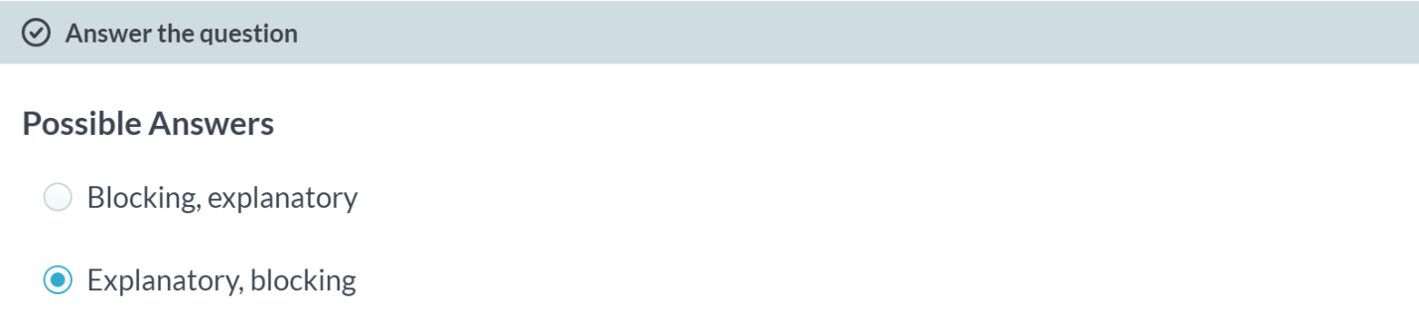  
The independent variable is called the **explanatory variable** (or better known as the predictor) - the variable which influences or predicts the values. i.e. if the explanatory variable changes then it affects the response variable. **Blocking variable** is a categorization **variable** for information within a dataset that is used to control, test, or manipulate the distribution and statistical results.

# Connect blocking and stratifying

In random sampling, we use ___ to control for a variable. In random assignment, we use ___ to achieve the same goal.

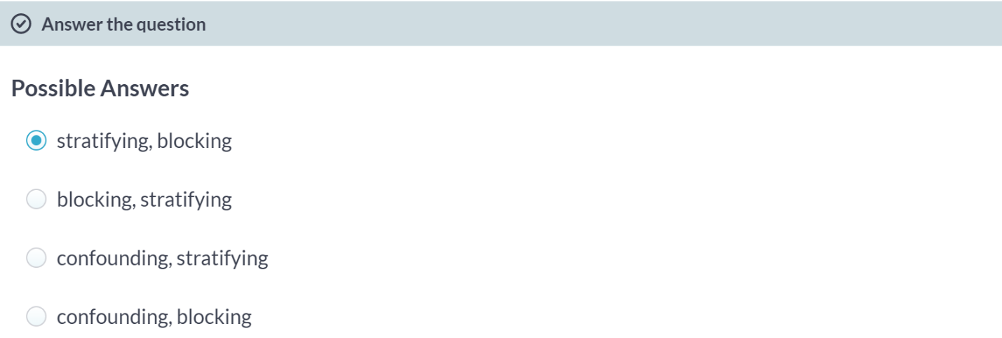

**Case study**Apply terminology, principles, and R code learned in the first three chapters of this course to a case study looking at how the physical appearance of instructors impacts their students' course evaluations.



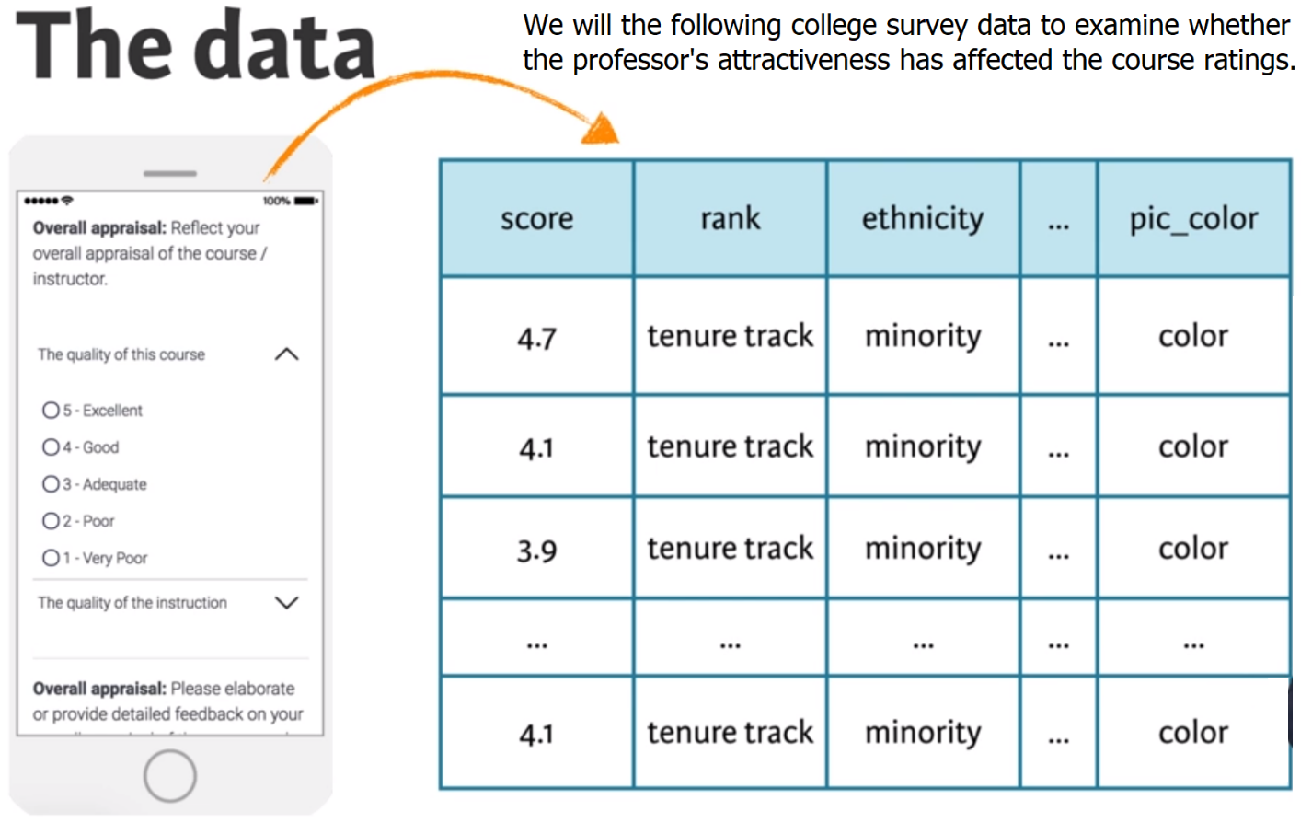

# Inspect the data

The purpose of this chapter is to give you an opportunity to apply and practice what you've learned on a real world dataset. For this reason, we'll provide a little less guidance than usual.

The data from the study described in the video are available in your workspace as evals. Let's take a look!

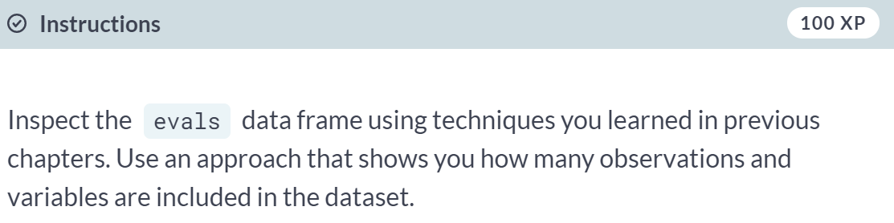

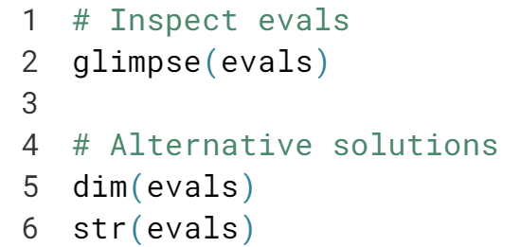

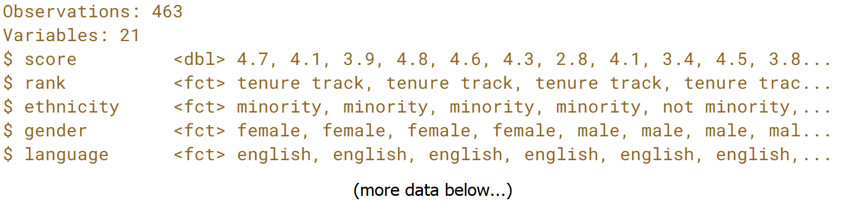  
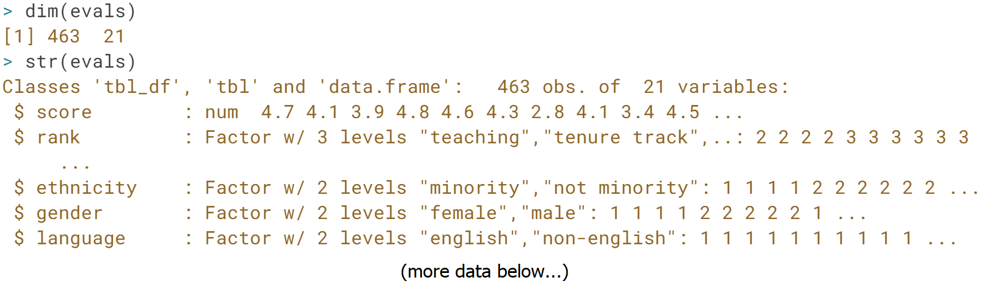  
Nice work! There are many ways to inspect a data frame in R and to find how many observations and variables it contains.

# Identify type of study

What type of study is this?

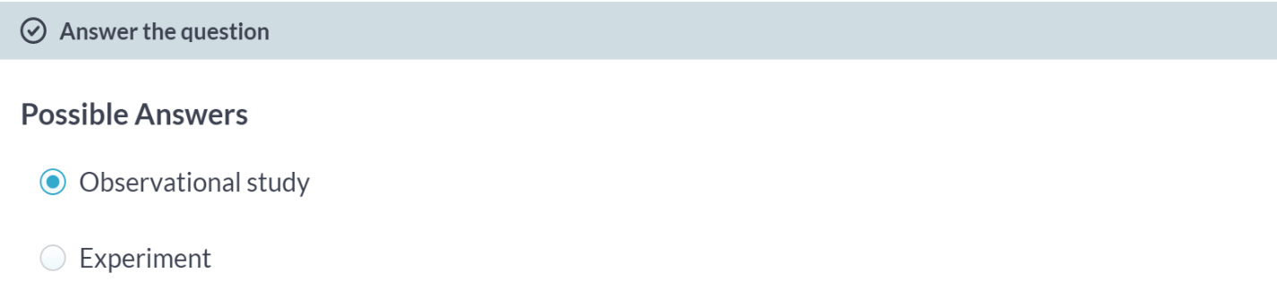Indeed, it is an observation study.

# Sampling / experimental attributes

The data from this study were gathered by ___.

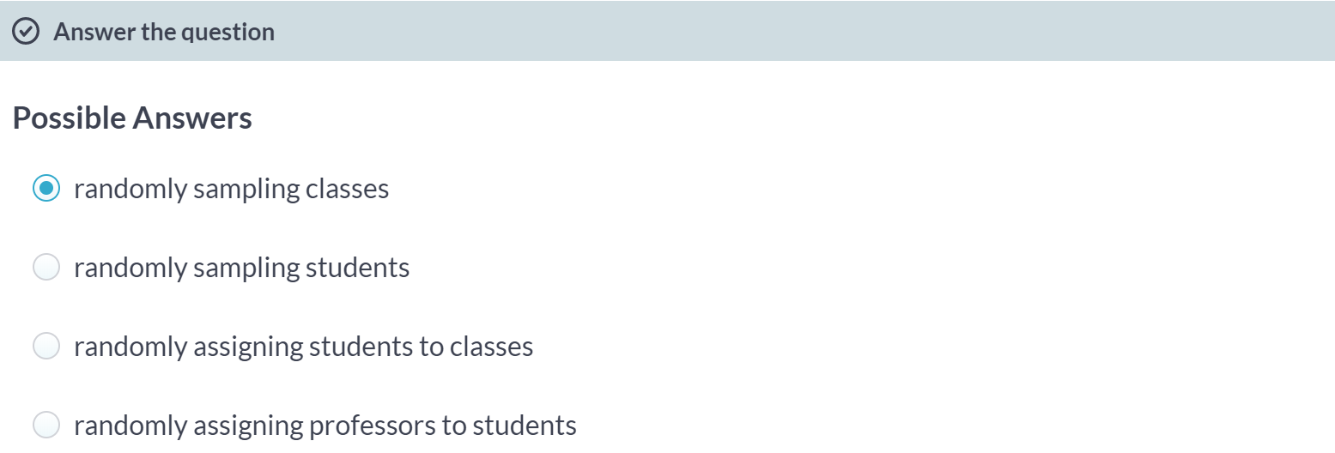



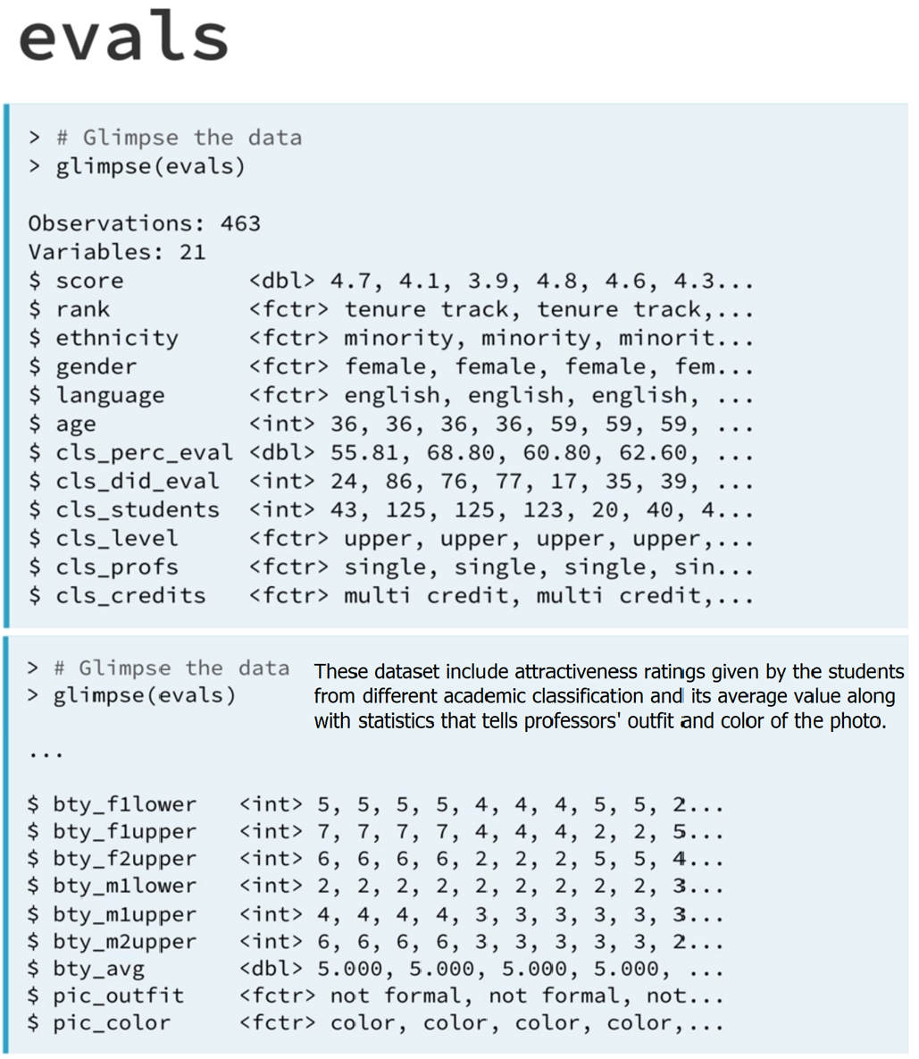

# Identify variable types

It's always useful to start your exploration of a dataset by identifying variable types. The results from this exercise will help you design appropriate visualizations and calculate useful summary statistics later in your analysis.

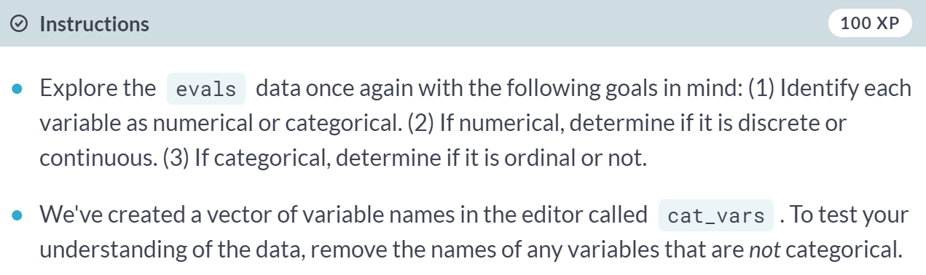

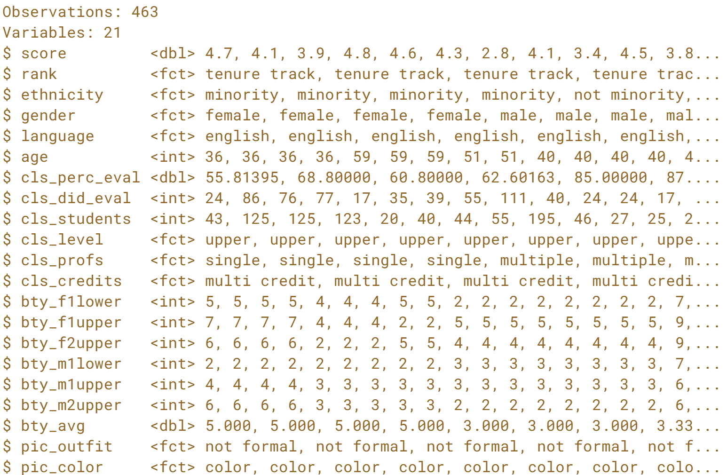  
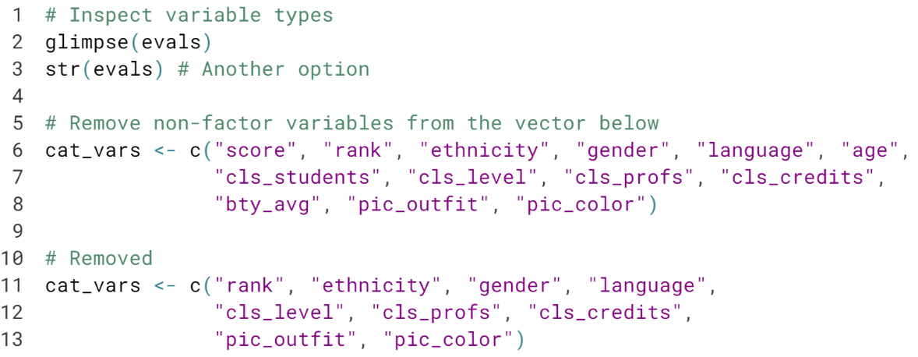  
Notice how all the *<dbl>* and *<int>* variables are removed.

# Recode a variable

The cls_students variable in evals tells you the number of students in the class. Suppose instead of the exact number of students, you're interested in whether the class is

* "small" (18 students or fewer),
* "midsize" (19 - 59 students), or
* "large" (60 students or more).

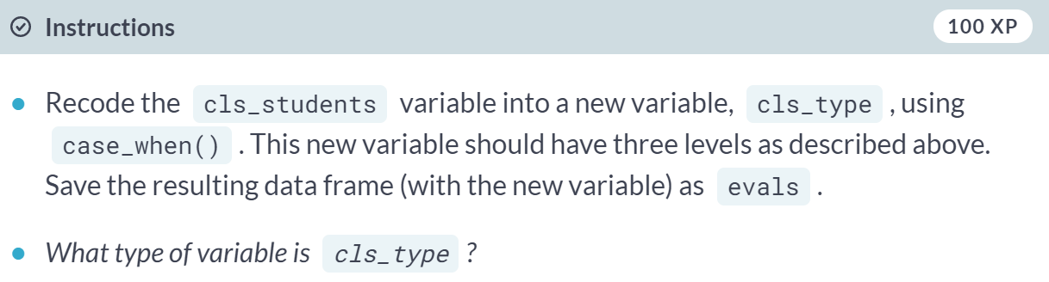

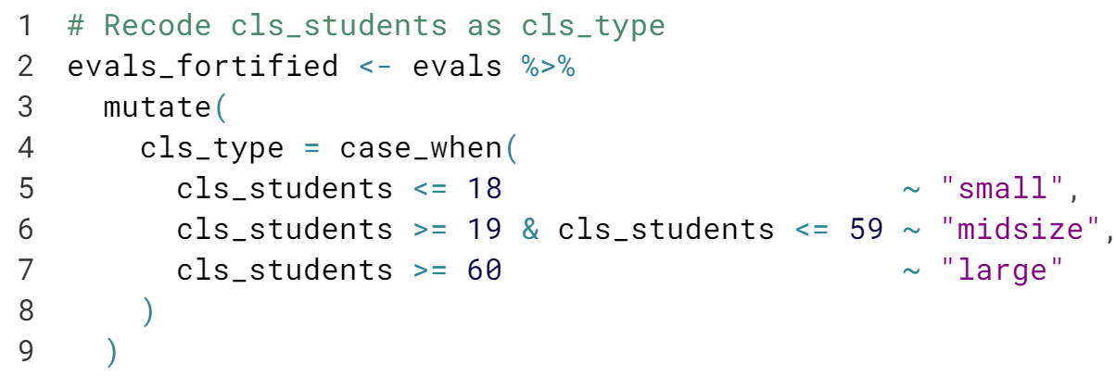

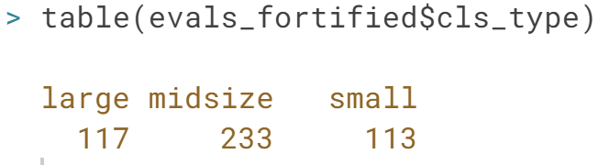  
Excellent! The *cls_type* variable is a categorical variable, stored as a character vector. You could have made it a factor variable by wrapping the nested ***ifelse()*** statements inside ***factor()***. You don't have to do that now. Let's move on!

# Create a scatterplot

The bty_avg variable shows the average beauty rating of the professor by the six students who were asked to rate the attractiveness of these faculty. The score variable shows the average professor evaluation score, with 1 being very unsatisfactory and 5 being excellent.

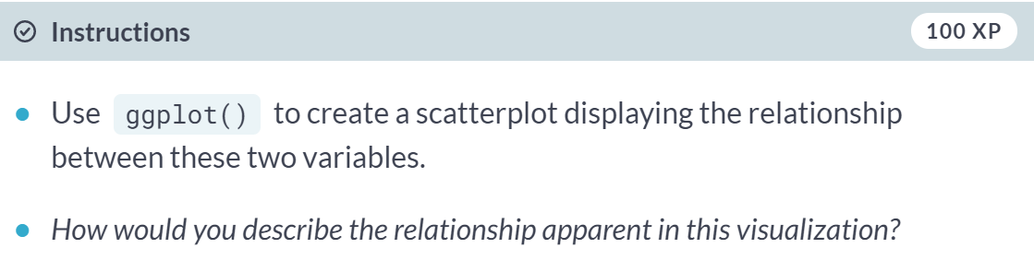

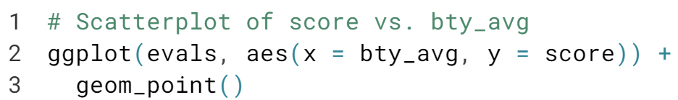

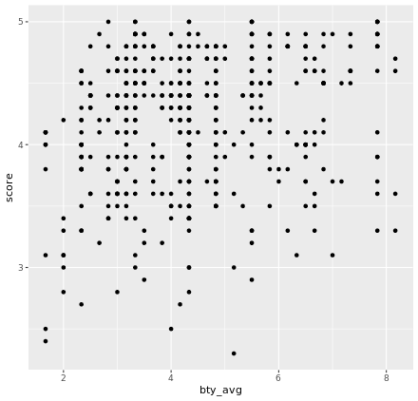

# Create a scatterplot, with an added layer

Suppose you are interested in evaluating how the relationship between a professor's attractiveness and their evaluation score varies across different class types (small, midsize, and large).

